**Marketing Research Written Report**

**Executive Summary**

The survey findings among Humber College students indicate a generally positive level of awareness regarding the United Nations Sustainable Development Goals (SDGs), with most respondents showing familiarity with them. While a significant portion believes Humber College contributes to the SDGs, there are gaps in visibility and engagement, particularly in participation in college-organized SDG events. There's recognition of the importance of measuring impact, though opinions vary on existing mechanisms. Communication of sustainability initiatives needs improvement, but there's consensus on the importance of integrating sustainability principles across campus operations.

This research indicates that Humber College can enhance its sustainability efforts by improving communication, establishing clearer measurement mechanisms, and fostering partnerships. Integrating sustainability principles into policies and curriculum, alongside offering diverse engagement opportunities, can empower students to contribute effectively to the SDGs. Addressing these recommendations will not only strengthen Humber College's sustainability initiatives but also cultivate a community of proactive sustainability advocates among its students.

1. **Introduction**

Humber College is dedicated to sustainability and plays a significant role in advancing the United Nations Sustainable Development Goals (UNSDGs). It actively contributes to a more sustainable future, aligning with the UNSDGs. With this research we plan to understand how Humber College is a leader in Sustainability, its Office of Sustainability takes the lead in creating sustainable campuses. They emphasize economic, social, and environmental sustainability throughout the college, fostering a culture of sustainability in operations, teaching, and learning.

Humber College’s integration into education, how sustainability is woven into all academic program curricula, ensuring that every Humber graduate becomes a career-ready citizen who comprehends and addresses global challenges. How it incorporates sustainable practices into campus development and operations. Initiatives include adhering to green building standards, implementing.

energy efficiency improvements, and providing real-world learning opportunities for students.

A commitment to Climate Action and how it aims for net-zero carbon emissions by 2050. They meticulously track greenhouse gas emissions through inventories and take steps to mitigate environmental impacts. Humber College has several recognitions and innovations, including NX Building at the North campus received accolades for its sustainability features after retrofitting. Additionally, the new construction at the Lakeshore campus, known as the Cultural Hub, follows sustainable methods such as utilizing mass timber.

As Humber College students, we are conducting research to explore Humber College’s proactive engagement in advancing the United Nations Sustainable Development Goals (UN SDGs).

**1.1 Following are the Research Objectives**

* Evaluate how well Humber College’s initiatives align with specific UNSDGs. Investigate the effects of these efforts on campus sustainability, student learning, and community engagement.
* Explore the incorporation of UNSDGs into academic programs and courses. Assess the effectiveness of teaching methods and materials related to sustainability and global challenges.
* Investigate how different stakeholders (students, faculty, staff, community partners) perceive and participate in UN SDG-related activities. Understand their motivations, barriers, and awareness levels.
* Identify successful practices, innovations, and case studies within Humber College that contribute to UNSDGs. Highlight examples of sustainable campus operations, student-led initiatives, and community partnerships.
* Examine obstacles faced by Humber College in advancing UNSDGs. Consider financial constraints, institutional policies, and cultural factors that may impede progress.
* Develop evidence-based recommendations to enhance Humber’s commitment to UNSDGs. Propose strategies for scaling up existing efforts and addressing gaps.

**1.2 Significance and importance of the study**

Colleges and universities play a pivotal role in advancing sustainability efforts. Investigating their impact reveals how they integrate sustainable practices across various domains, including education, research, operations, and community partnerships. By understanding their role, we can inform policies and practices that contribute to a more sustainable world.

Education and research are key components. Humber College educates future generations, and by examining how they incorporate sustainability into their curriculum, they inspire students to address global challenges. Additionally, research conducted by colleges provides valuable insights into effective approaches for achieving the SDGs.

Curriculum integration ensures that all students, regardless of their field of study, understand the importance of sustainable development. By mainstreaming sustainability, Humber College prepares graduates to contribute to a more equitable and environmentally viable world.

Lastly, multi-stakeholder engagement is crucial. Humber College actively participates in partnerships for the SDGs, collaborating with researchers and students. This engagement fosters knowledge transfer and provides essential tools for successful SDG implementation.

Ongoing research on the role of Humber Colleges in sustainability remains crucial for several reasons. Firstly, the dynamic context of sustainability necessitates continuous assessment. The landscape of sustainability is constantly evolving. What worked in the past may not be effective today. What worked in the past may not be effective today, and new challenges emerge. Secondly, further studies uncover innovative approaches and best practices. By examining successful sustainability initiatives, we can identify strategies that other institutions can adopt. Thirdly, localized studies delve deeper into specific contexts. Colleges operate within unique ecosystems, and tailored research helps address local needs. Lastly, robust measurement tools and accountability mechanisms rely on ongoing research. By refining metrics, we ensure that institutions remain committed to their sustainability goals. In summary, continuous investigation ensures that colleges adapt, contribute meaningfully, and remain at the forefront of sustainability efforts.

**1.3 Definition of terms and concepts**

* **Sustainability** - It encompasses economic, environmental, and social dimensions, aiming for long-term balance and well-being.
* **No Poverty** - End Poverty in all its forms everywhere
* **Zero Hunger** - It achieved food security and improved nutrition and promote sustainable agriculture
* **Good Health and Well Being** - Ensure Health lives and promote well being for all at all stages
* **Quality Education** - Ensure inclusive and equitable quality education and promote lifelong learning opportunities for all
* **Gender Equality** - Achieve Gender Equality and empower all women and girls
* **Clean Water & Sanitation** - Ensure Availability & Sustainable management of Water Sanitation for all
* **Affordable and Clean Energy** - Ensure access to affordable, reliable, sustainable and modern energy for all
* **Decent Work and Economic Growth** - Promote sustained, inclusive and sustainable economic growth, full and productive employment and decent work for all
* **Industry Innovation and Infrastructure** - Build resilient infrastructure, promote inclusive and sustainable industrialization and foster innovation
* **Reduce Inequalities** - Reduce inequality within and among countries
* **Sustainable Cities and Communities** - Make cities and human settlements inclusive, safe, resilient and sustainable
* **Responsible Consumption and Production** - Ensure sustainable consumption and production patterns
* **Climate Action** - Take urgent action to combat climate change and its impacts
* **Life Below Water** - Conserve and sustainably use the oceans, seas and marine resources for sustainable development
* **Life on Land** - Protect, restore and promote sustainable use of terrestrial ecosystems, sustainably manage forests, combat desertification, and halt and reverse land degradation and halt biodiversity loss
* **Peace, Justice and Strong Institutions** - Promote peaceful and inclusive societies for sustainable development, provide access to justice for all and build effective, accountable and inclusive institutions at all level
* **Partnerships for the Goals** - Strengthen the means of implementation and revitalize the Global Partnership for Sustainable Development

1. **Literature Review**

**2.1 Overview of previous Research on the topic**

Several researches have been done on Humber Colleges sustainability program that are in relation to United Nation Sustainable Development Goals. A particular study was done and a goal was set by Humber College’s sustainability department called Integrated Energy Master PLan (IEMP). This plan aligns with UNSDGs as the plan focuses on The current global energy and water landscape presents both opportunities and uncertainties. The Paris Climate Agreement emphasizes the need to reduce carbon emissions urgently. Changing weather patterns and water usage stress natural resources. Energy consumption is growing, reshaping markets for oil and gas suppliers. Upgrading older energy and water systems improves flexibility and reliability. Technology offers cleaner and more efficient energy and water supply options. In response, Humber College developed an Integrated Energy Master Plan (IEMP) to maximize opportunities and minimize risks over the next two decades. Their goal is to double energy and water efficiencies, reduce carbon emissions by at least 30%, and create economically attractive outcomes. Additionally, Humber aims to offer academic programs related to integrated energy planning. Despite being better than average among similar colleges in Ontario and North America, Humber’s energy intensity remains higher than global standards.

In a business-as-usual scenario, where student growth and new construction coincide with energy and water price uncertainties, utility costs are projected to increase significantly by 2034. The carbon footprint is also expected to rise, despite provincial plans calling for substantial emissions reductions. To address this, Humber College has developed an Integrated Energy Master Plan (IEMP) that aims to achieve breakthrough results. The IEMP includes measures such as upgrading heating and cooling networks, integrating campus-wide modern networks, and implementing energy centers for clean and reliable energy. Additionally, the plan focuses on creating a Smart Energy Network through upgraded metering and control capabilities. The investment required for these initiatives is approximately $66M by 2034, with a strong emphasis on efficiency improvements in buildings. Humber’s Energy and Sustainability organization will oversee implementation, engaging faculty, staff, students, and stakeholders. The IEMP will also support a range of academic programs, serving the energy planning needs of communities and industry.

Humber College’s Integrated Energy Master Plan (IEMP), developed collaboratively over the past year, has exceeded its objectives. The recommended solution includes measures to:

* Increase energy efficiency by 50%
* Improve water efficiency by 54%
* Decrease absolute carbon emissions by 60%
* Achieve an Internal Rate of Return between 10% and 17%
* Establish itself as a North American Centre of Academic Excellence for Integrated Energy Solutions

The IEMP’s progress will be continuously monitored, ensuring adjustments as needed. Metrics such as energy end-use indexes, water efficiency, and cost savings will be tracked at various levels. Additionally, the success of related academic programs will be reviewed. By rigorously implementing the IEMP, Humber College aims to achieve world-class energy and climate performance, becoming a leader in both operations and academics within Ontario and Canada.

Our secondary research was helpful as it helped us establish a relation between a company and sustainability, Humber College is also an institution that requires this. The article on Competitive Sustainability: The Intersection of Sustainability and Business Success showed us

Competitive sustainability, unlike its non-performing counterpart, directly impacts business success. Recognizing this connection encourages businesses to adopt sustainable practices and discard non sustainable ones.

Competitive sustainability combines environmental preservation with financial advantage. Urgent action is needed to replace non sustainable practices. Lennox and Toffel’s study highlights information sharing as key for successful adoption of competitive environmental practices across business units, especially when subsidiaries lack relevant knowledge.

Both internal and external pressures impact the adoption of competitive environmental practices. While informal competition drives green innovation, access to credit influences this relationship. Lack of knowledge can hinder adoption, but motivation matters. Subsidiaries may ignore practices from the home office, yet competitive pressure can drive innovation, including sustainability efforts

In a study applying a competitive dynamics perspective, a rival firm’s sustainability performance influenced the focal firm’s sustainability efforts. Awareness, motivation, and capability drove the competitive response. Interestingly, the rival’s strategy not only prompted sustainability pursuit but also led to similar adoption by the focal firm. Larger firms were more likely to imitate competitive sustainability practices. Well-established firms also defended their markets. Rapid responses in closely monitored industries intensified the competitive reaction. Applying competitive dynamics theory aids understanding of how competitive sustainability combats unsustainable practices.

Competitive sustainability, informed by resource-based theory, involves bundling resources to create a stronger core competency. Sustainable products, preferred by environmentally conscious consumers, outperform innovative and undifferentiated ones. Interestingly, combining sustainability and innovation doesn’t yield greater success than standalone sustainable products. Positioning sustainability as innovation enhances competitiveness. However, consumer awareness of sustainability aspects remains a challenge. Additionally, micro level evidence shows that grassroots entrepreneurs, driven by various motivations, contribute to competitive sustainability.

Competitive sustainability involves multifaceted motivations. While necessity drives profit-seeking goals and consumer needs, other motives coexist. For Kenyan entrepreneurs, the link between business success and environmental preservation is evident due to climate change’s impact on their local economy. Importantly, motivations need not be mutually exclusive; making a living can harmonize with community and environmental contributions. However, traditional thinking often misguides practitioners and academics. Despite evidence that sustainability enhances competitiveness, the prevailing assumption remains that it harms profitability. Paradoxically, the knowledge barrier may amplify its advantage for those who recognize and pursue it—until competitors catch up.

For sustainability-minded entrepreneurs, whether grassroots (as in [8]) or established companies considering competitive sustainability, caution is warranted. Initiatives to transition from a linear to a circular economy often rely on disruptors introducing sustainable products [9]. However, if these disruptors succeed, rivals previously non-sustainable may imitate their achievements. While established rivals may need persuasion [2], their eventual response to the novel venture’s ongoing success is likely [4,5]. From an environmental perspective, the industry-wide shift toward sustainability may seem positive. Yet, for entrepreneurs and innovators, the risk lies in their novel sustainable ventures losing ground when established companies follow suit [5].

The interplay between environmental optimism and entrepreneurial concerns lies in the transition toward sustainability within industries. Initially, greening efforts may render original sustainable ventures less necessary. However, this adaptation doesn’t guarantee sustained motivation for further improvements. Failed sustainable companies leave room for incumbents to take up the mantle.

For optimal outcomes:

* Environmentalists should appreciate incumbents’ sustainability efforts while hoping original entrepreneurs continue to thrive.
* Consumers favor sustainability, but this doesn’t necessarily incentivize companies to be first movers.
* While coupling sustainability with other innovations has limited evidence [6], green innovation remains a competitive element [4].
* Stakeholder awareness is crucial; they respond positively when recognizing sustainability’s benefits [1]. Effective information diffusion to stakeholders is critical [2,3].
* Competitive dynamics theory emphasizes a dynamic approach to maintain a sustainability advantage [5].

The article “The Circular Economy – A new sustainability paradigm?” was also another study that supported our research that said the Circular Economy is a regenerative system that aims to minimize resource waste by closing material and energy loops. It achieves this through practices like repair, reuse, remanufacturing, and recycling. On the other hand, sustainability involves balancing economic performance, social inclusiveness, and environmental resilience for both current and future generations. Recent research trends show increased interest in the Circular Economy, particularly among Chinese and European scholars. However, despite their frequent use in similar contexts, the conceptual differences between sustainability and the circular economy have not been explicitly clarified in the literature. This paper seeks to address this gap by highlighting their similarities and differences, shedding light on their practical implications. Furthermore, the relationship between the Circular Economy and sustainability varies in literature: it can be seen as a condition for sustainability, a beneficial relation, or even a trade-off. Managers and policymakers can adopt diverse strategies to integrate these concepts effectively.

The article “When food systems meet sustainability – Current narratives and implications for actions” delved into the concept of sustainability within food systems. We emphasized how the merging of sustainability and human health into the overarching idea of a “sustainable diet” can obscure critical challenges and tensions between different objectives. Despite widespread use, the concept of sustainability remains poorly understood and narrowly applied across various communities.

Our argument centers on the need to transition from general food systems to sustainable food systems. We identified four key entry points that reveal critical challenges for policy-making and research in this domain. Specifically, there is an urgent need to precisely define what constitutes a sustainable food system, including which dimensions of sustainability should be considered. Notably, social and economic dimensions often receive insufficient attention within the conventional sustainability framework.

Local-Specific Nature of Food Systems: We must explicitly recognize that food systems are inherently local. This goes beyond geographical aspects and extends to cultural and social dynamics. Rather than envisioning a monolithic “global food system,” we should consider a multitude of interconnected local food systems. These local systems can be aggregated and linked at higher levels, such as through international trade. However, incorporating the “cultural acceptability” dimension into food system discussions remains challenging. While culturally acceptable food is essential, it may not always align with sustainability goals.

Trade-Offs in Sustainable Food Systems: We need to acknowledge trade-offs within food systems. Balancing food security, nutrition, health, income, environmental sustainability, and culture is complex. Recent reports sometimes oversimplify these trade-offs, emphasizing win-win solutions. Instead, we should focus on understanding and navigating these trade-offs more effectively and equitably.

Political Economy Dimension: Adopting a sustainable food system agenda requires recognizing its political economy dimension. Multiple actors—local and national governments, private sectors, and civil society organizations—play crucial roles. Effective dialogue among these stakeholders hinges on clarifying the complexities of sustainable food systems and addressing trade-offs and interactions.

**2.2 Identification of gaps in the literature**

Our attention has been drawn to the absence of a specific study on Humber College’s alignment with the United Nations Sustainable Development Goals (UNSDGs). While the college has engaged in sustainable practices, a direct connection to the UNSDGs has not been established. Although the college’s sustainability development website highlights achieved goals, comprehensive data or studies are lacking. Our research seeks to bridge this gap by demonstrating how Humber College has successfully met numerous sustainability objectives, showcasing its leadership in this critical area.

**2.3 Development of Hypotheses or Research questions**

Hypothesis: - If Humber college contributes towards U.N. S.D.Gs, then it will increase its reputation and brand recognition

**2.4 Summary of key findings and implications for the current study**

**Key findings from Previous studies -**

1. Integrated Energy Master Plan (IEMP): Humber College has developed an IEMP to maximize energy and water efficiencies, reduce carbon emissions, and create economically attractive outcomes.
2. Energy Efficiency Goals: The IEMP aims to double energy efficiency and improve water efficiency by 54%.
3. Carbon Emission Reduction: The plan targets a decrease of absolute carbon emissions by 60%.
4. Financial Impact: The IEMP aims for an Internal Rate of Return between 10% and 17%.
5. Academic Excellence: Humber College seeks to establish itself as a North American Centre of Academic Excellence for Integrated Energy Solutions.
6. Investment and Oversight: Approximately $66M investment is required by 2034, overseen by Humber’s Energy and Sustainability organization.
7. Continuous Monitoring: Progress will be continuously monitored, adjusting as needed.
8. Academic Support: The IEMP will also support related academic programs, serving energy planning needs.
9. Leadership Ambition: Humber aims to lead in both operations and academics within Ontario and Canada
10. Competitive Sustainability: Unlike its non-performing counterpart, competitive sustainability directly impacts business success. Recognizing this connection encourages businesses to adopt sustainable practices and discard non sustainable ones.
11. Environmental Preservation and Financial Advantage: Competitive sustainability combines environmental preservation with financial advantage. Urgent action is needed to replace non sustainable practices.
12. Information Sharing: Lennox and Toffel’s study highlights information sharing as key for successful adoption of competitive environmental practices across business units, especially when subsidiaries lack relevant knowledge.
13. Internal and External Pressures: Both internal and external pressures impact the adoption of competitive environmental practices. Informal competition drives green innovation, while access to credit influences this relationship.
14. Rival Firm Influence: Applying a competitive dynamics perspective, a rival firm’s sustainability performance influences the focal firm’s sustainability efforts. Larger firms are more likely to imitate competitive sustainability practices.
15. Resource-Based Theory: Sustainable products, preferred by environmentally conscious consumers, outperform innovative and undifferentiated ones. Combining sustainability and innovation doesn’t yield greater success than standalone sustainable products.
16. Grassroots Entrepreneurs: Micro-level evidence shows that grassroots entrepreneurs, driven by various motivations, contribute to competitive sustainability.
17. Kenyan Entrepreneurs: For Kenyan entrepreneurs, the link between business success and environmental preservation is evident due to climate change’s impact on their local economy.
18. Knowledge Barrier: Despite evidence that sustainability enhances competitiveness, the prevailing assumption remains that it harms profitability. The knowledge barrier may amplify its advantage for those who recognize and pursue it—until competitors catch up.
19. Circular Economy: The circular economy aims to minimize resource waste by closing material and energy loops through practices like repair, reuse, remanufacturing, and recycling.
20. Sustainability: Sustainability involves balancing economic performance, social inclusiveness, and environmental resilience for both current and future generations.
21. Conceptual Differences: Despite frequent use, the conceptual differences between sustainability and the circular economy have not been explicitly clarified in the literature.
22. Practical Implications: This paper seeks to address the gap by highlighting the similarities and differences between sustainability and the circular economy, shedding light on their practical implications.
23. Relationship Variation: The relationship between the circular economy and sustainability varies in literature, ranging from a condition for sustainability to a beneficial relation or even a trade-off.
24. Food Systems and Sustainability: The article “When food systems meet sustainability – Current narratives and implications for actions” emphasizes the need to transition from general food systems to sustainable food systems.
25. Critical Challenges: Four key entry points reveal critical challenges for policy-making and research in sustainable food systems.
26. Precise Definition: There is an urgent need to precisely define what constitutes a sustainable food system, including which dimensions of sustainability should be considered.

**The implications for current study:-**

1. Circular Economy and Sustainability: Understanding the conceptual differences between the circular economy and sustainability is crucial. While the circular economy aims to minimize waste through practices like repair and recycling, sustainability involves balancing economic, social, and environmental aspects. Managers and policymakers should recognize their distinct yet interconnected roles.
2. Challenges in Sustainable Food Systems: Transitioning from general to sustainable food systems requires precise definitions and consideration of various dimensions of sustainability. Stakeholders’ awareness and effective information diffusion play critical roles. Policymakers and researchers must address challenges related to sustainability, health, and consumer preferences.
3. Competitive Sustainability: Businesses should recognize that competitive sustainability directly impacts success. While combining sustainability with innovation doesn’t necessarily yield greater success, positioning sustainability as innovation enhances competitiveness. Grassroots entrepreneurs contribute to competitive sustainability, emphasizing the need for multifaceted motivations.
4. Industry Shifts and Entrepreneurial Risks: As industries shift toward sustainability, entrepreneurs face risks. Novel sustainable ventures may lose ground when established companies follow suit. Environmentalists should appreciate incumbents’ efforts while hoping original entrepreneurs continue to thrive. Effective information diffusion and dynamic strategies are essential to maintain a sustainability advantage.
5. Holistic Approach: Integrating sustainability and circular economy concepts requires a holistic approach. Businesses should recognize that sustainability extends beyond environmental aspects to include social and economic dimensions. A comprehensive understanding ensures effective decision-making.
6. Consumer Awareness: Despite consumer preferences for sustainable products, awareness remains a challenge. Companies must bridge the gap by effectively communicating the sustainability aspects of their offerings. Educating consumers about the value of sustainable choices is essential.
7. Strategic Positioning: Positioning sustainability as innovation enhances competitiveness. Companies should strategically align sustainability efforts with market demands. Recognizing that sustainability can confer a competitive advantage encourages proactive adoption.
8. Dynamic Adaptation: Competitive sustainability requires dynamic adaptation. As competitors catch up, industry leaders must stay ahead by continuously innovating. Flexibility and responsiveness are critical to maintaining a sustainability advantage.
9. Stakeholder Engagement: Engaging stakeholders—both internal and external—is crucial. Managers, policymakers, and researchers should collaborate to integrate sustainability effectively. Stakeholder awareness drives adoption and supports sustainable practices.
10. Balancing Objectives: Balancing sustainability and business success is essential. Entrepreneurs and established companies must navigate the tension between profitability and environmental impact. A nuanced approach considers diverse motivations and objectives.
11. Industry Leadership: Industry leaders play a pivotal role. Their sustained commitment to sustainability sets the tone for others. By championing sustainable practices, they contribute to a broader shift toward more responsible and resilient systems.

**3. Methodology**

**3.1 Description of the Research Design and Data Collection methods**

**Descriptive research design -**

**Focus Group:** The idea behind doing the focus group session was to know about the knowledge the students have regarding our topic. Firstly, we prepared a set of questions and discussed those questions with a group consisting of 6 members in our course. The response we received from other group members stated that more of them were aware of the Role of Humber College in relation to the U.N SDGs then the ones that weren’t. The focus group was conducted for a total of an hour and a half and was led by an appointed moderator from our group who was responsible for leading the discussion and asking the relevant questions needed for the primary research. The focus group consisted of 10 open-ended questions from “how has Humber impacted climate action and sustainable cities and communities goals in the college?” To that “how do you see collaborations between governments, businesses, civil society organizations at Humber College contributing to achievement of sustainable development?”

**Objective:** The objective of the survey is to gather insight on the awareness, involvement and the perceptions of the Humber community regarding the U.N SDGs. We aimed to first, to understand the level of familiarity with the concept of U.N SDGs among the students and respondents, then tried to identify which sustainable development goals had been seen promoted at the College. We also tried to assess personal commitment to sustainability and the principles of the goals amongst the respondents, gauge the perceptions of the Humber College’s contribution to the achievement of the U.N SDGs, then finally collecting suggestions on how the College can enhance its efforts in regards to the SDGs and the future directions that can be taken regarding these goals.

**3.2 Description of the Sample and Data Analysis procedures**

**Data Analysis Procedure:** The data analysis procedure was mainly based on pie charts, bar charts and multiple choice, which shows that the responses were analyzed using descriptive statistics. Some of the procedure taken are;

**Data collection:** Responses were collected for each survey question by the team.The questions for the survey was derived with the use of Artificial intelligence, each group member was tasked to explore a range of different AI to produce questions for the survey then the questions were combined and narrowed down into a total of 21 questions according to what related to the topic the most and would bring more responses. Moreover, every member of our group selected a few questions by themselves and then we all discussed what are the best questions we could present in our Survey Questionnaire.

**Percentage calculation:** the percentage of respondents choosing each option was calculated by dividing the frequency of each response by the total number of responses. In the survey, the percentage for each response option is typically calculated by dividing the hunger of respondents who selected that option by the total number of respondents. This fraction is then multiplied by 100 to convert into a percentage. For example, if a question had 25 responses and 11 respondents selected the options “Very Committed”, this would mean that 44% of the respondents selected the “Very Committed “ option for that question.

**Data visualization:** the results were then visualized using pie charts which represent each response option as a slice of the whole, illustrating the proportion of respondents choosing each option relative to the total responses and bar charts for easy interpretation. The bar charts were used in the survey to represent the questions where multiple answers could be selected. For example, in the question about how Humber college can enhance its efforts towards U.N SDGs, the responses are represented as a bar chart. Each bar corresponds to a different response option, and the length of the bar represents the percentage of respondents who have selected that option. The visualizations provide a clear and concise way to understand the distribution of responses to each question, making it easier to interpret the results of the survey. They allow for a quick comparison between different response options and can highlight trends or patterns in the data .

**Population:** During this survey Questionnaire we tried to reach out all campuses of Humber college and the responses we received were 92.7% of individuals were from the Lakeshore Campus whereas, 7.3% of the population were from the Humber college’s North campus and there were no participants from the Humber IGS campus.

**Sample Size:** There were 21 questions included in the survey form, out of which few were multiple choice questions(including the U.N SDGs) and others were more related to the general information that the public has about the Role of Humber college in relation to the U.N SDGs. At last we received 41 responses from the students and in addition, we received 8 responses providing suggestions on how Humber college should promote the SDG’s.

**Sampling Method:** The sampling method used for this survey is a convenience sampling. It is a type of non- probability sampling where the first available primary data source is used for the research without additional requirement. In this case, the survey was distributed to students who were really available and willing to participate at their own convenience. Voluntary response sampling was also included in this survey as it was shared via email, social media and other platforms for those who chose to respond.

**3.3 Description of the Validity and Reliability measures**

**Content Validity:** We aimed for the survey questions to represent the construct being measured. The questions accurately represent the various aspects of the sustainable development goals and Humber colleges visible efforts towards those goals.

**Construct validity:** We also subbed for the survey to measure exactly what it was intended to measure. The survey aims to measure awareness of the U.N sustainable development goals, the survey questions were selected accurately to capture this.

**3.4 Discussion of Limitations and Potential Sources of Bias**

**Limitations:**

Sample size: the sample size of the responses was 41 , which is relatively small and may limit the generalisability of the results to the entire population of Humber college

**Potential Sources of Bias:**

Selection bias: the survey was not distributed randomly among the population at Humber college, therefore the results may be biased towards the views of a specific group.

Response bias: those who chose to respond to the survey might have stronger opinions or more interest in the U.N SDGs, which could skew the results.

Social Desirability bias: respondents may have answered in a way that they believe is socially acceptable or favorable rather than their true opinions , most especially on topics like sustainability and UN SDGs.

**4. Results**

**4.1 Summary of the findings**

**Total Sample Size -** 41

**Target Audience -** Humber College Student

**Awareness of U.N. SDGs:**

82% of respondents (34 individuals) are familiar with the United Nations Sustainable Development Goals (U.N. SDGs), whereas 18% (7 individuals) lack familiarity with them.

**Perception of Humber College's Contribution to U.N. SDGs:**

According to 63% of respondents (26 individuals), Humber College contributes to U.N. SDGs, while 37% (15 individuals) believe it does not.

**Participation in College-Organized Events related to U.N. SDGs:**

75% of respondents (31 individuals) did not participate in events or activities organized by the college towards U.N. SDGs, while 25% (10 responders) participated in such events or activities.

**Measurement of Impact at Humber College:**

* 29% of respondents (12 individuals) advocate for the implementation of comprehensive measurement systems at Humber College to assess its impacts.
* 14% (6 responders) believe that there is currently no clear measurement approach in place at Humber College to measure its impacts.
* 57% (23 participants) are of the opinion that some measurement mechanisms already exist to gauge the impact of Humber College towards U.N. SDGs.

**Communication of Sustainability Initiatives at Humber College:**

* 36% of respondents (15 individuals) perceive that Humber College communicates its sustainability initiatives to students, staff, and the wider community moderately.
* 7% (3 responders) feel that Humber College does not effectively communicate its sustainability initiatives to these stakeholders at all.
* 29% (12 respondents) believe that Humber College communicates its sustainability initiatives to students, staff, and the wider community slightly effectively.
* 26% (11 participants) consider Humber College's communication of sustainability initiatives to be very effective.

**Ways to Encourage Student Engagement with SDGs at Humber College:**

* 20% of respondents (8 individuals) believe that offering more sustainability-focused courses and programs is the best approach.
* 17% (7 responders) advocate for organizing workshops and guest lectures as the most effective method.
* 2% (1 respondent) suggests providing volunteer opportunities related to the SDGs.
* 61% (25 participants) believe that a combination of all three options (sustainability-focused courses, workshops/guest lectures, and volunteer opportunities) is the best approach to encourage student engagement with the SDGs.

**Challenges Faced by Humber College in Aligning Activities with UN SDGs:**

* + **Lack of awareness or understanding:**
    - 19% (8 respondents) identify this as a primary challenge.
  + **Lack of awareness or understanding and Institutional barriers:**
    - 7% (3 respondents) believe these two factors together pose challenges.
  + **Lack of resources:**
    - 12% (5 responders) view this as a significant obstacle.
  + **Lack of resources & Institutional barriers:**
    - 2% (1 respondent) see these as combined challenges.
  + **Lack of resources & Lack of awareness or understanding:**
    - 7% (3 respondents) identify these as concurrent challenges.
  + **Lack of resources, Lack of awareness or understanding & Institutional barriers:**
    - 2% (1 respondent) believe these three factors collectively present challenges.
  + **Lack of resources & Resistance to change:**
    - 2% (1 respondent) perceive these as interconnected challenges.
  + **Lack of resources, Resistance to change & Lack of awareness or understanding:**
    - 7% (3 respondents) think these three challenges intersect.
  + **Lack of resources, Resistance to change, Lack of awareness or understanding & Institutional barriers:**
    - 5% (2 participants) identify these four factors as intertwined challenges.
  + **Resistance to change:**
    - 9% (4 respondents) view this as a standalone challenge.
  + **Resistance to change & Institutional barriers:**
    - 2% (1 respondent) see these two factors as linked challenges.
  + **Resistance to change & Lack of awareness or understanding:**
    - 19% (8 respondents) believe these two challenges are connected.

**Importance of Incorporating Sustainability Principles into Humber College's Operations:**

* + **Extremely important:**
    - 65% (27 respondents) consider this level of importance.
  + **Somewhat important:**
    - 5% (2 participants) view sustainability incorporation with moderate importance.
  + **Very important:**
    - 13% (12 responders) perceive sustainability incorporation as highly significant.

**Participation in Sustainability-Related Events at Humber College:**

* + **Not interested and no participation:**
    - 7% (3 respondents) fall into this category.
  + **Interested but no participation:**
    - 63% (26 participants) express interest but haven't participated.
  + **Multiple participations:**
    - 7% (3 responders) have participated in multiple sustainability-related events.
  + **Single participation:**
    - 22% (9 respondents) have participated once in such events.

**Effectiveness of Feedback Mechanisms for SDG-related Initiatives at Humber College:**

* + **Effective:**
    - 19% (8 respondents) believe the feedback mechanisms are effective.
  + **Not Effective at All:**
    - 2% (1 respondent) perceive the feedback mechanisms as not effective.
  + **Not Very Effective:**
    - 9% (4 respondents) consider the feedback mechanisms to be not very effective.
  + **Somewhat Effective:**
    - 39% (16 respondents) find the feedback mechanisms somewhat effective.
  + **Very Effective:**
    - 29% (12 respondents) believe the feedback mechanisms are very effective.

**Campus Culture Influence at Humber College by the SDGs:**

* **Moderately Influenced:**
  + 12 respondents (29%) believe that the campus culture at Humber College is moderately influenced by the SDGs.
* **Strongly Influenced:**
  + 17 respondents (41%) believe that the campus culture at Humber College is strongly influenced by the SDGs.
* **Very Strongly Influenced:**
  + 9 respondents (22%) believe that the campus culture at Humber College is very strongly influenced by the SDGs.
* **Weakly Influenced:**
  + 3 respondents (7%) believe that the campus culture at Humber College is weakly influenced by the SDGs.

**Awareness of SDG-related Initiatives at Humber College:**

* **Not Seen Any Initiatives:**
  + 16 respondents (39%) have not seen any initiatives at Humber College related to the SDGs.
* **Seen Initiatives:**
  + 25 respondents (61%) have seen initiatives at Humber College related to the SDGs.

**Promotion of UN SDGs at Humber College:**

* **Not Seen Any Promotion:**
  + 16 respondents (39%) have not seen any promotion at Humber College in relation to UN SDGs.
* **Seen Promotion of Specific SDGs:**
  + 4 respondents (9%) have seen Decent Work and Economic Growth (SDG 8) promoted at Humber College.
  + 4 respondents (9%) have seen Decent Work and Economic Growth (SDG 8) & Gender Equality (SDG 5) promoted at Humber College.
  + 8 respondents (19%) have seen Decent Work and Economic Growth (SDG 8), Gender Equality (SDG 5), & Responsible Consumption and Production (SDG 12) promoted at Humber College.
  + 3 respondents (7%) have seen Gender Equality (SDG 5) promoted at Humber College.
  + 5 respondents (12%) have seen Gender Equality (SDG 5) & Responsible Consumption and Production (SDG 12) promoted at Humber College.
  + 1 respondent (2%) has seen Responsible Consumption and Production (SDG 12) promoted at Humber College.

**Prioritization of SDGs by Respondents for Humber College:**

* **No Poverty:**
  + 6 respondents (14%) prioritize No Poverty.
* **Zero Hunger:**
  + 6 respondents (14%) prioritize Zero Hunger.
* **Good Health & Well-Being:**
  + 17 respondents (41%) prioritize Good Health & Well-Being.
* **Quality Education:**
  + 20 respondents (49%) prioritize Quality Education.
* **Gender Equality:**
  + 16 respondents (39%) prioritize Gender Equality.
* **Clean Water & Sanitation:**
  + 12 respondents (29%) prioritize Clean Water & Sanitation.
* **Affordable & Clean Energy:**
  + 15 respondents (37%) prioritize Affordable & Clean Energy.
* **Decent Work & Economic Growth:**
  + 19 respondents (46%) prioritize Decent Work & Economic Growth.
* **Industry, Innovation & Infrastructure:**
  + 13 respondents (32%) prioritize Industry, Innovation & Infrastructure.
* **Reduced Inequalities:**
  + 22 respondents (54%) prioritize Reduced Inequalities.
* **Sustainable Cities and Communities:**
  + 19 respondents (46%) prioritize Sustainable Cities and Communities.
* **Responsible Consumption and Production:**
  + 22 respondents (54%) prioritize Responsible Consumption and Production.
* **Climate Action:**
  + 21 respondents (51%) prioritize Climate Action.
* **Life Below Water:**
  + 6 respondents (15%) prioritize Life Below Water.
* **Life on Land:**
  + 7 respondents (17%) prioritize Life on Land.
* **Peace, Justice & Strong Institutions:**
  + 25 respondents (61%) prioritize Peace, Justice & Strong Institutions.
* **Partnerships for the Goals:**
  + 26 respondents (63%) prioritize Partnerships for the Goals.

**Enhancement Suggestions for Humber College Efforts towards UN SDGs:**

* **Increasing student involvement and awareness:**
  + 22 respondents (54%) suggest increasing student involvement and awareness.
* **Enhancing research initiatives focused on SDGs:**
  + 10 respondents (24%) suggest enhancing research initiatives focused on SDGs.
* **Integrating SDGs into campus operations and policies:**
  + 9 respondents (22%) suggest integrating SDGs into campus operations and policies.
* **Strengthening partnerships with external organizations:**
  + 11 respondents (27%) suggest strengthening partnerships with external organizations.

**Initiatives Desired for Humber College:**

* **Enhance global partnerships:**
  + 2 respondents (5%) would like to see initiatives focused on enhancing global partnerships.
* **Expanding current initiatives:**
  + 15 respondents (37%) would like to see initiatives focused on expanding current initiatives.
* **Focus on new SDGs:**
  + 3 respondents (7%) would like to see initiatives focused on new SDGs.
* **Not sure about the direction:**
  + 5 respondents (12%) are uncertain about the direction Humber College should take.
* **Increase community engagement:**
  + 16 respondents (39%) would like to see initiatives focused on increasing community engagement.

**Levels of Commitment towards Sustainability and UN SDGs:**

* **Not committed at all:**
  + 2 respondents (5%) are not committed at all towards sustainability and the principles of the UN SDGs.
* **Somewhat committed:**
  + 24 respondents (58%) are somewhat committed towards sustainability and the principles of the UN SDGs.
* **Very committed:**
  + 15 respondents (37%) are very committed towards sustainability and the principles of the UN SDGs.

**Suggestions from Respondents:**

* **No further suggestions:**
  + 37 respondents (90%) don't have any further suggestions.
* **Suggestions provided:**
  + 4 respondents (10%) have suggestions to give.

**Suggestions by Responders:**

* Establishing information stations in the L building to enhance sustainability consciousness, detailing Humber College’s initiatives in this area, and outlining ways students can participate.
* Humber College should focus on integrating education on Sustainable Development Goals (SDGs) into their course syllabi. As awareness among students increases, so too will their involvement in assisting Humber to attain these objectives.
* Expanding the range of student support programs in relation to U.N. S.D.Gs
* Organizing events focused on student involvement and Sustainable Development Goals to enhance awareness.
* It’s essential that Humber College increases student awareness about Sustainable Development Goals. By doing so, students can become key contributors to the college’s sustainability efforts.
* Humber College should strive to enhance student engagement and participation in sustainability initiatives.

**4.2 Tables, Graphs, or Other Visual aids to present the data**

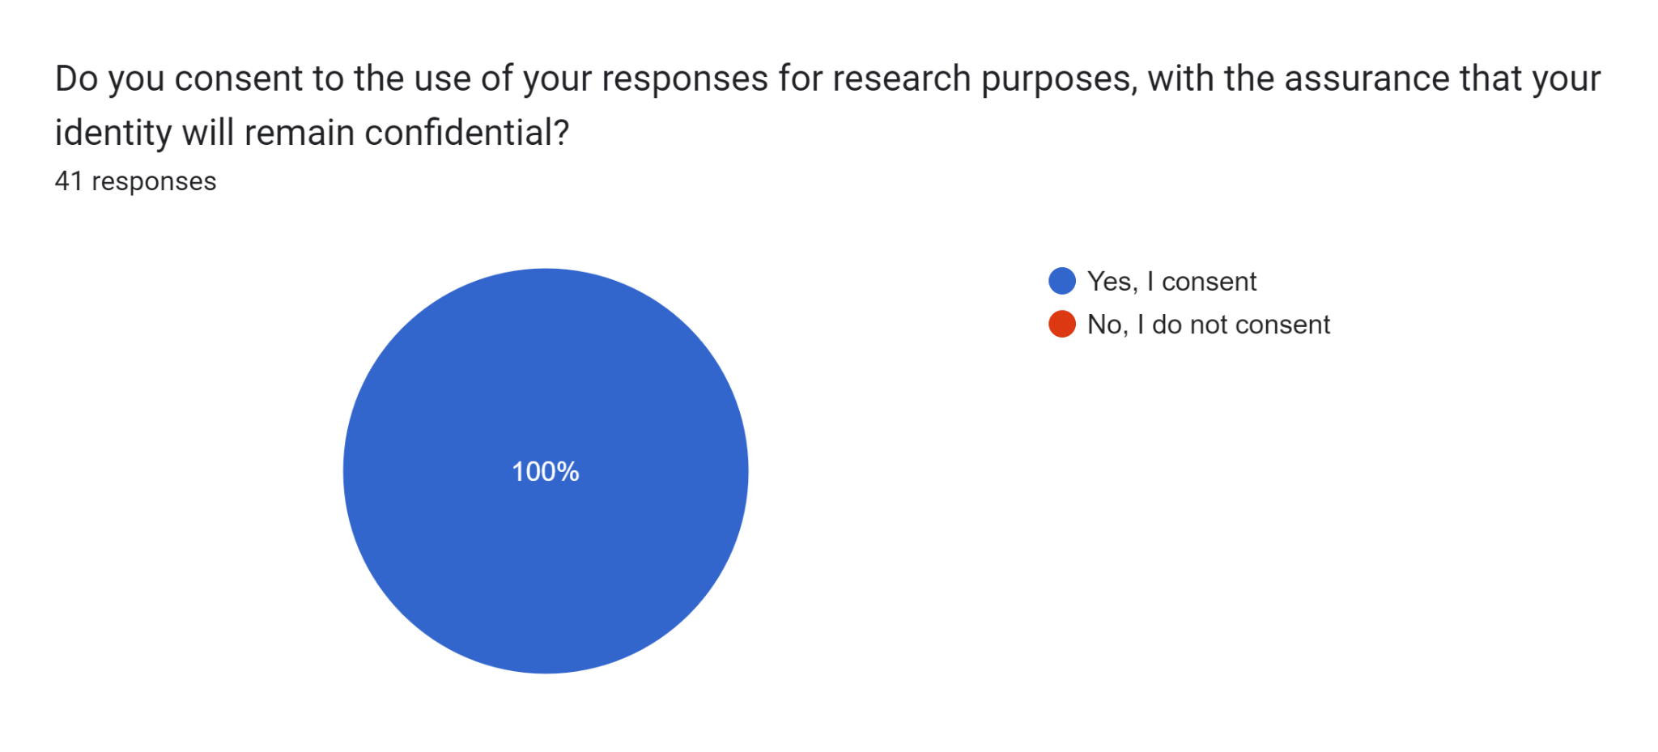

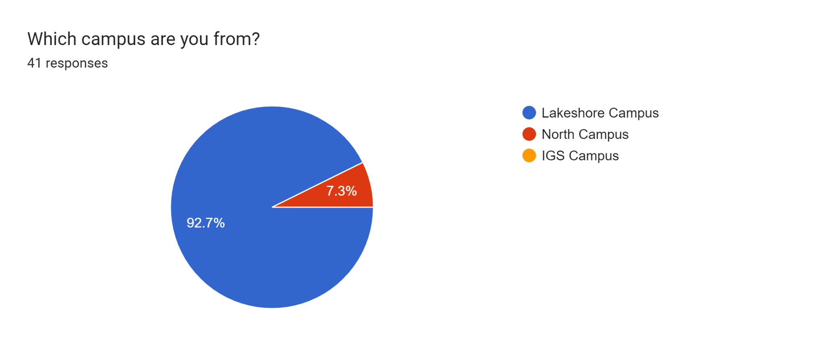

Forms response chart. Question title: 1. How familiar are you with the concept of United Nation Sustainable Development Goals (SDGs)?
. Number of responses: 41 responses.

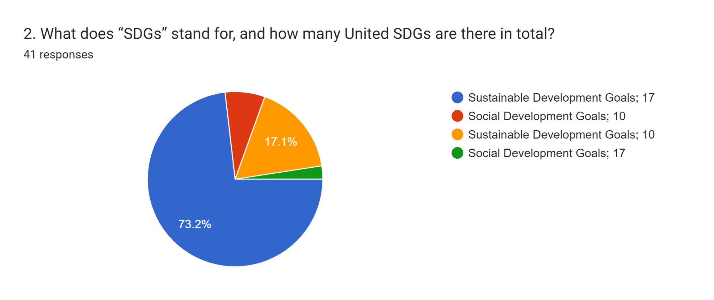

Forms response chart. Question title: 3. Do you think Humber College contributes to the accomplishment of the United Nation Sustainable Development Goals (SDGs)?
. Number of responses: 41 responses.

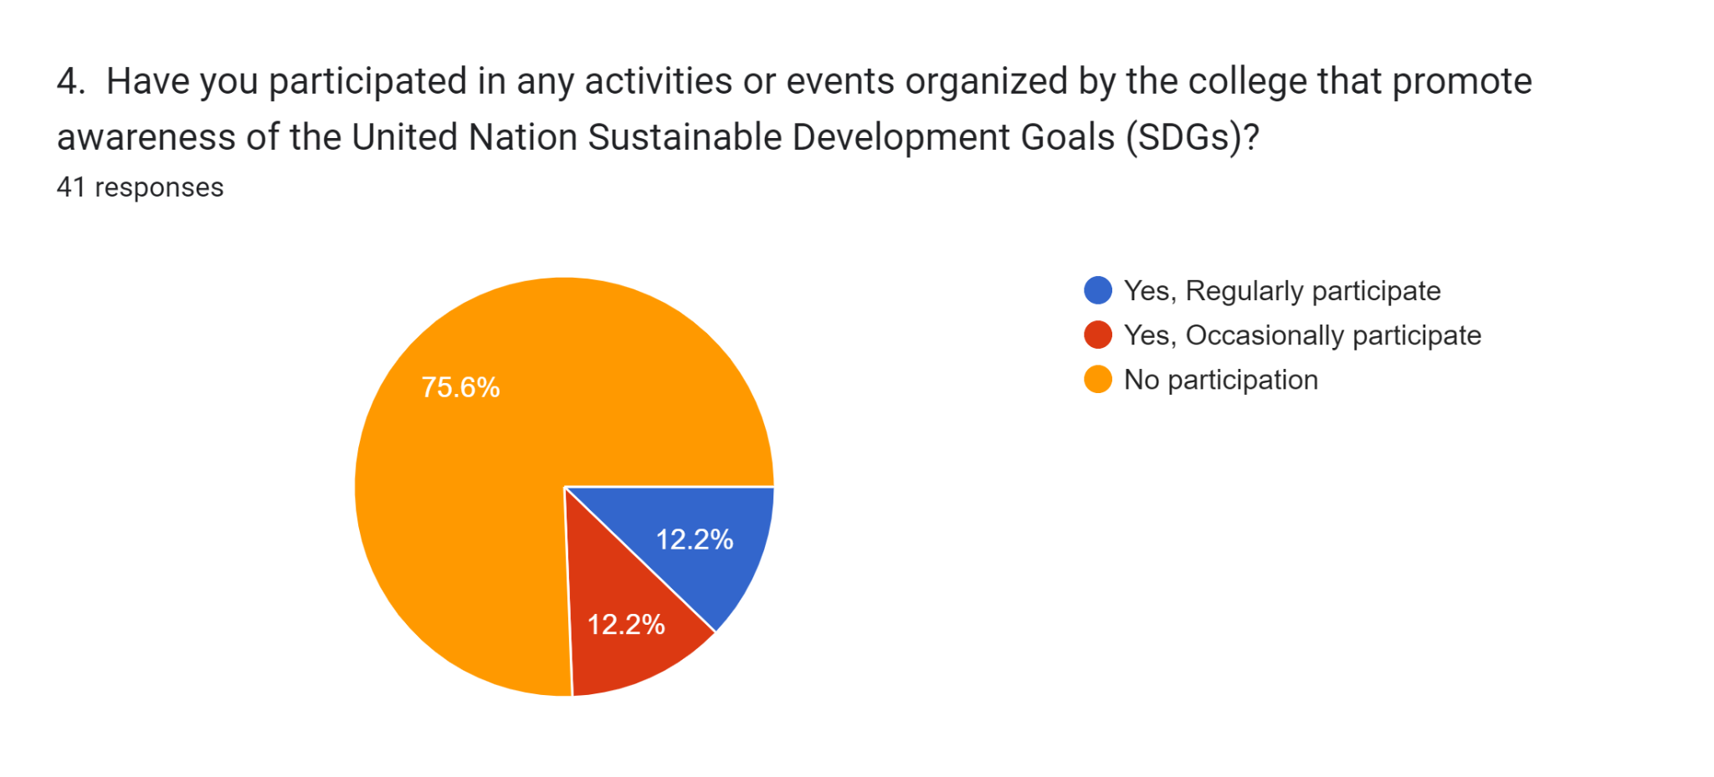

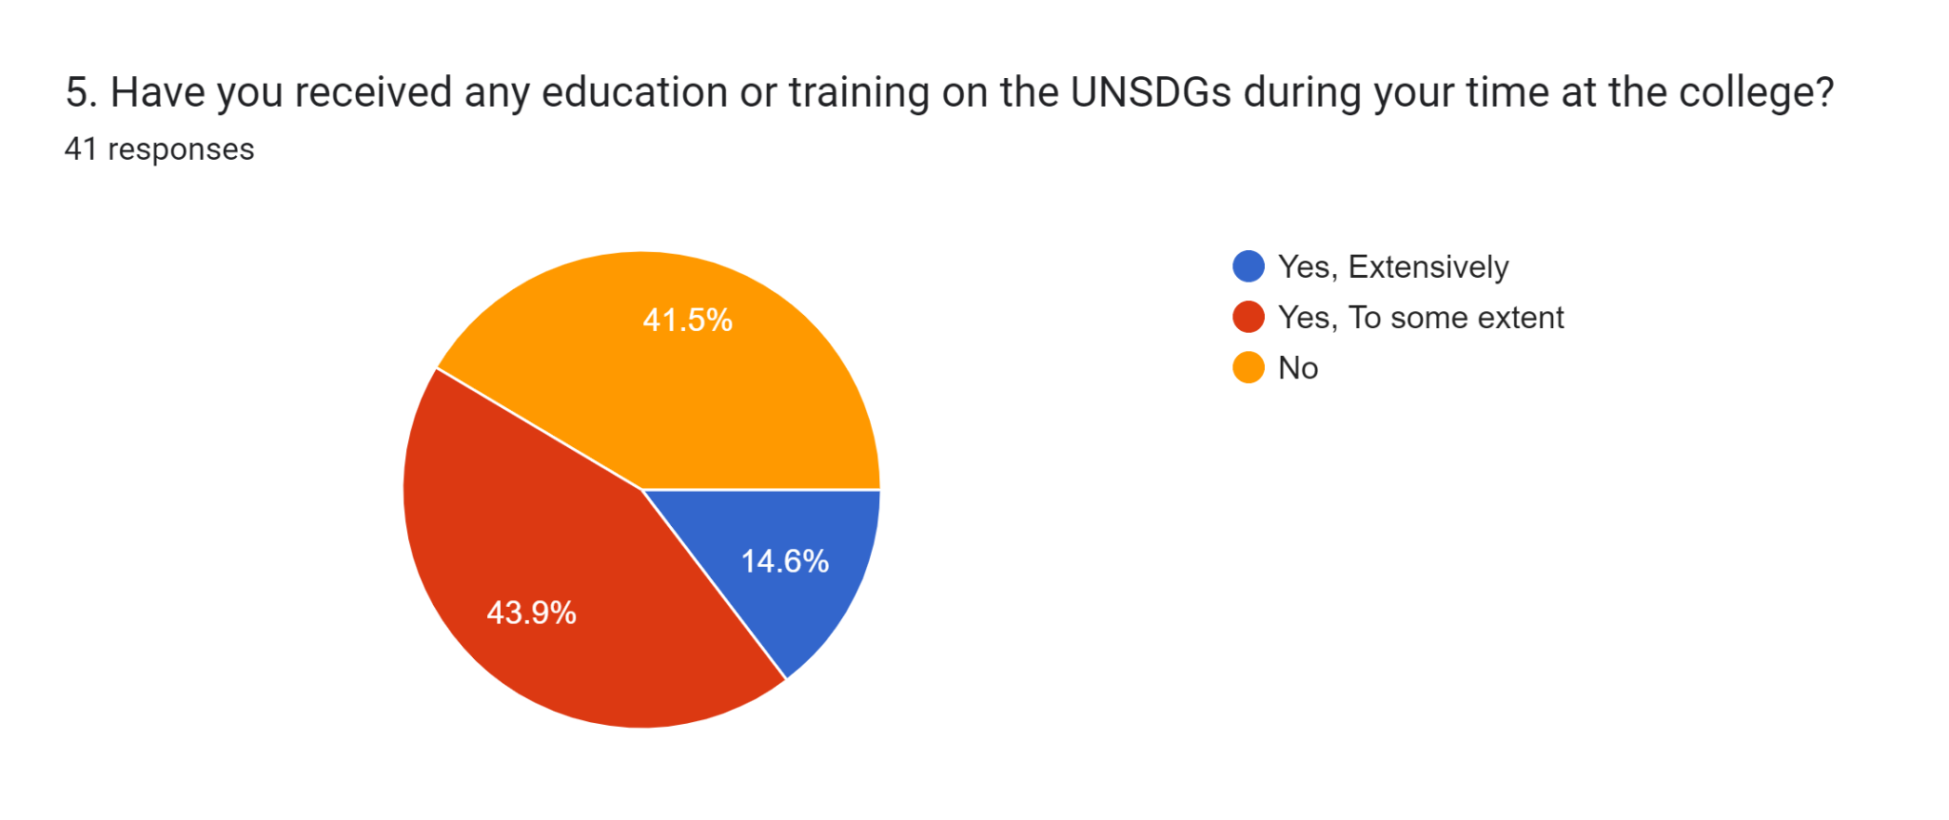

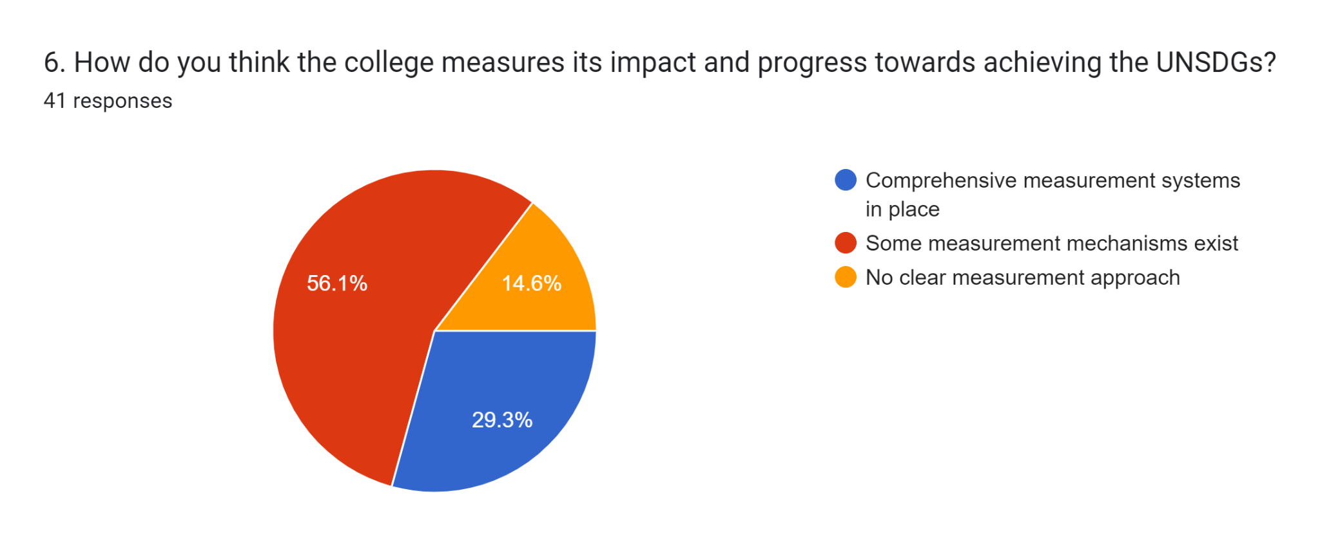

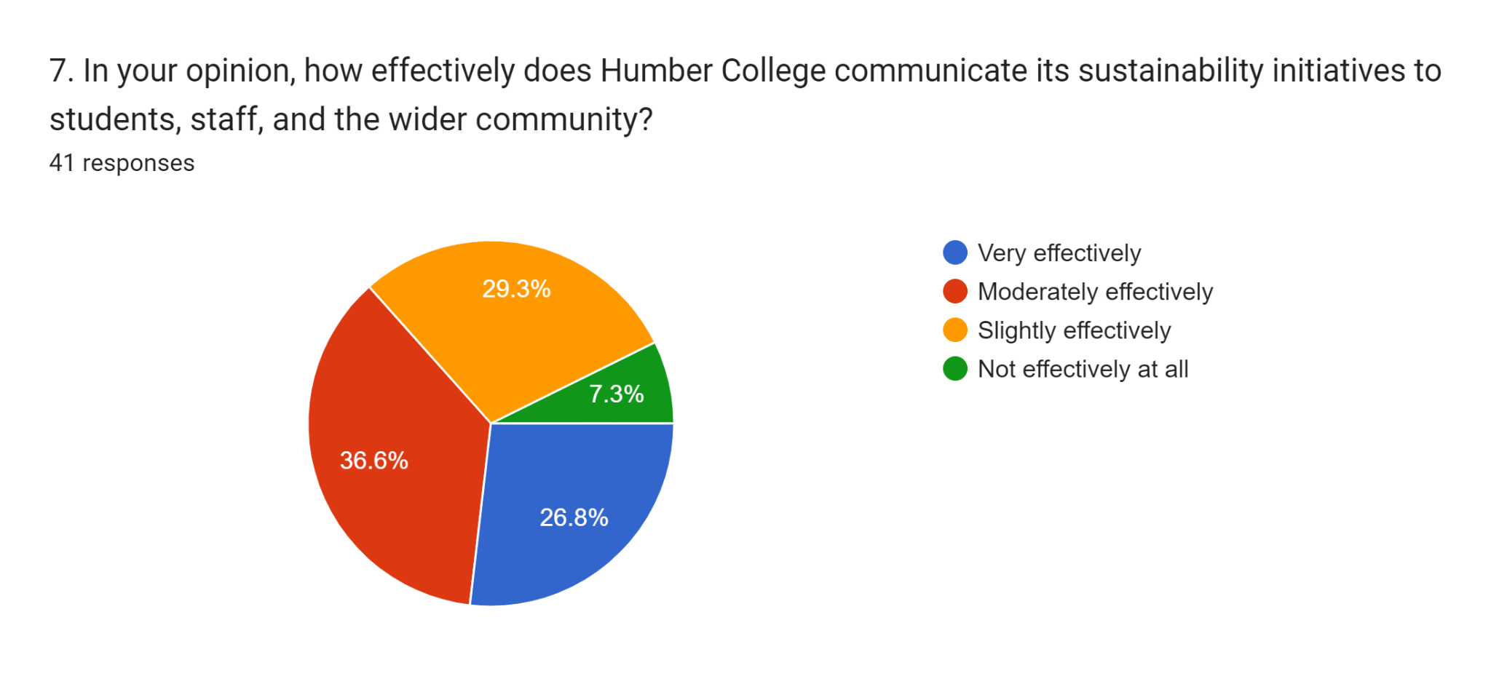

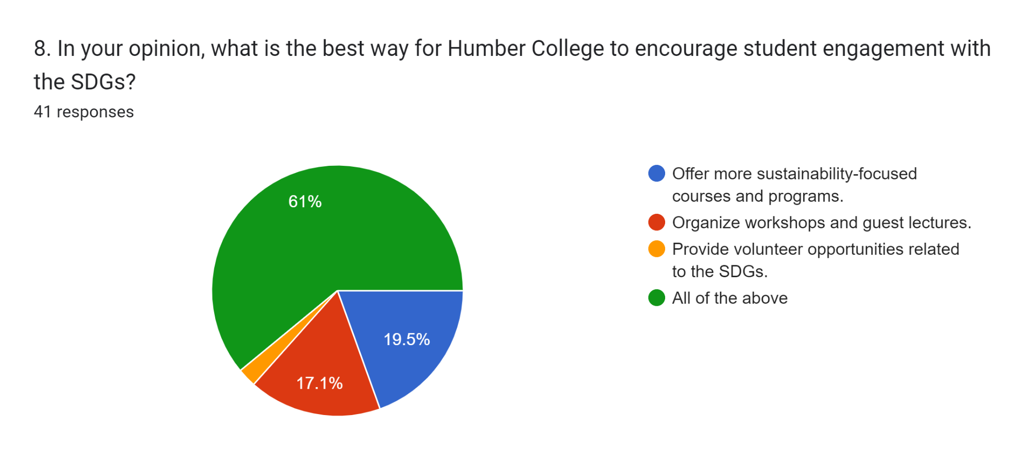

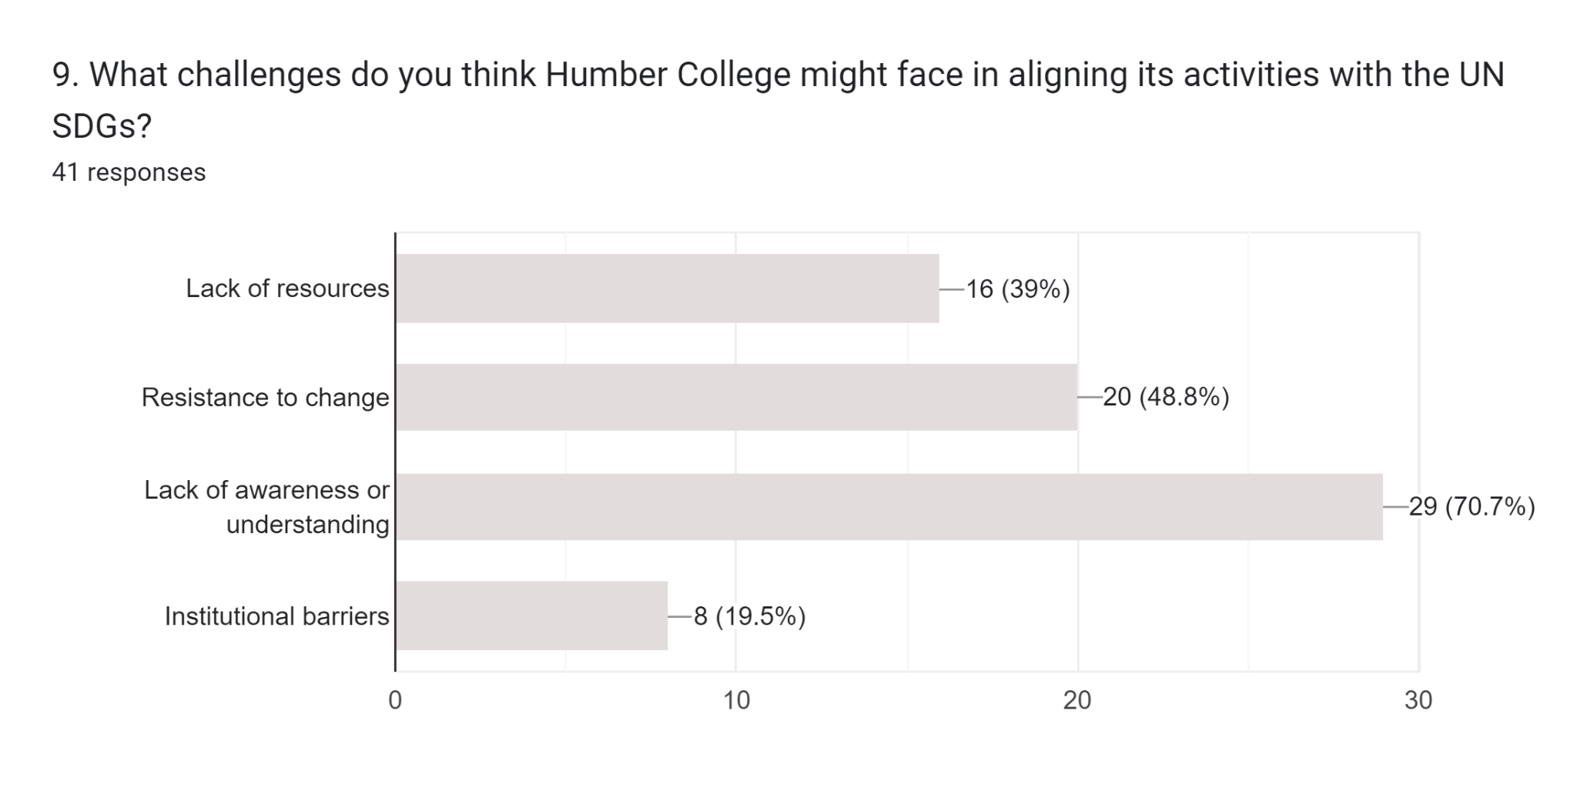

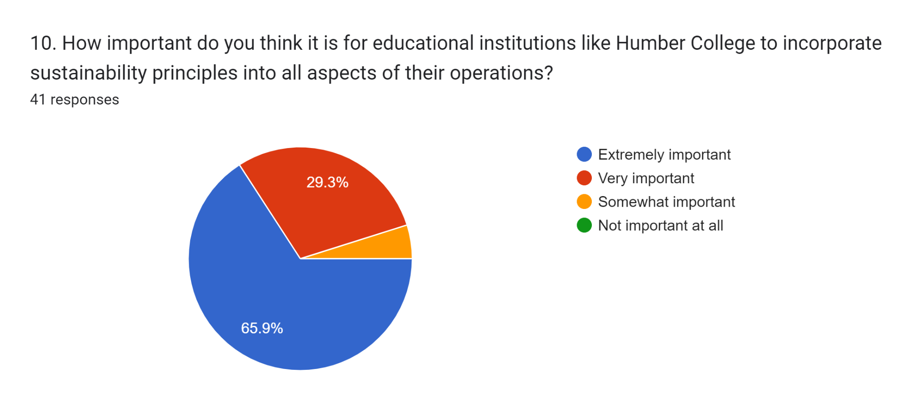

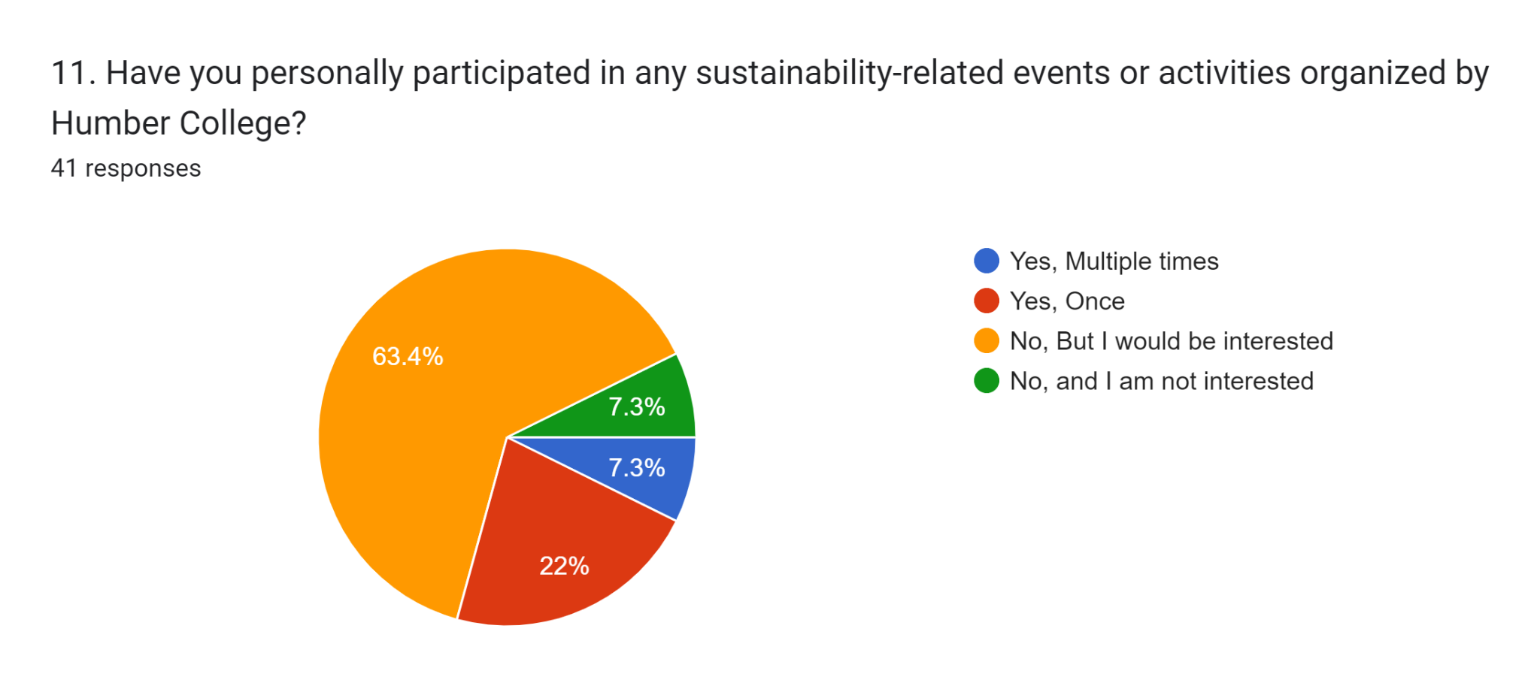

Forms response chart. Question title: 12. How effective are the feedback mechanisms for SDG-related initiatives at Humber College?
. Number of responses: 41 responses.

Forms response chart. Question title: 13. How strongly is the campus culture at Humber College influenced by the SDGs?
. Number of responses: 41 responses.

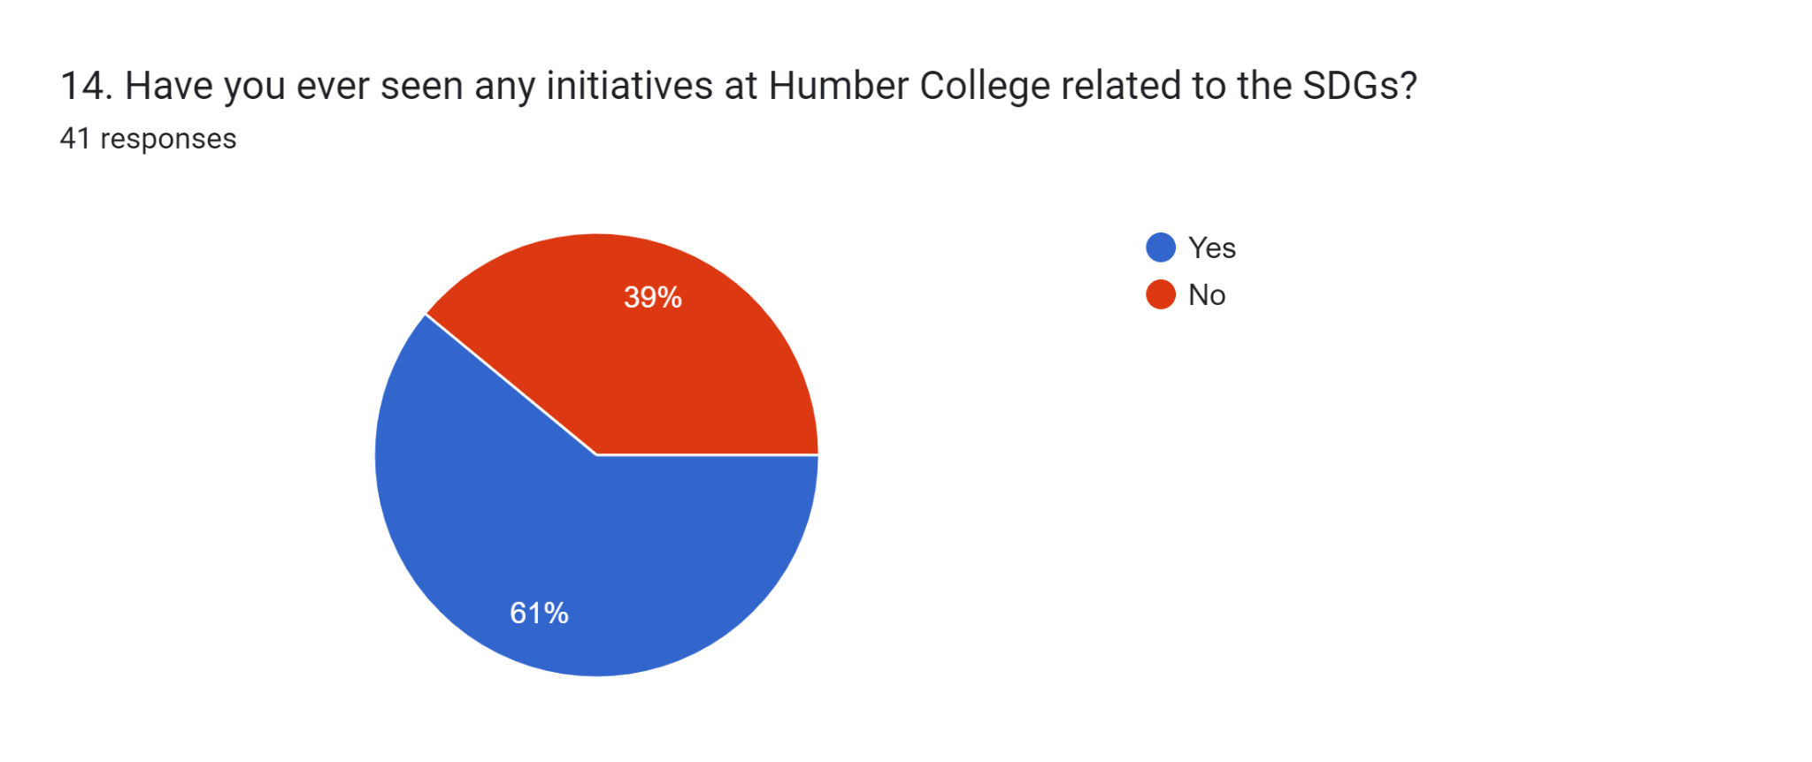

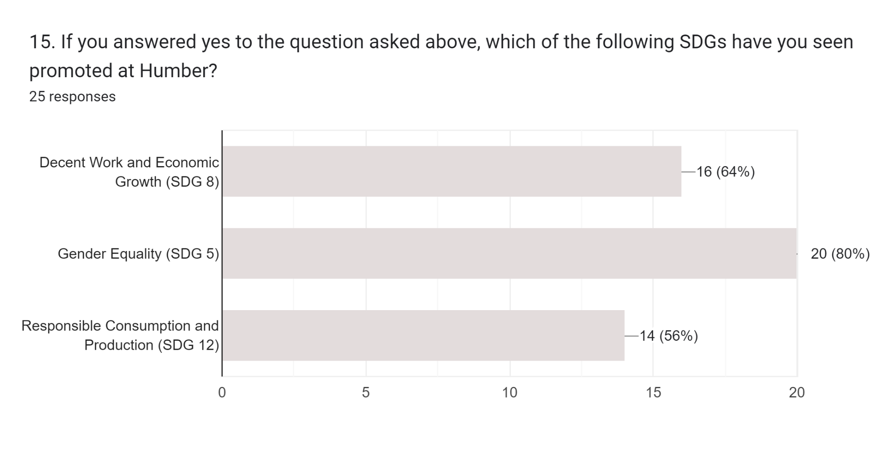

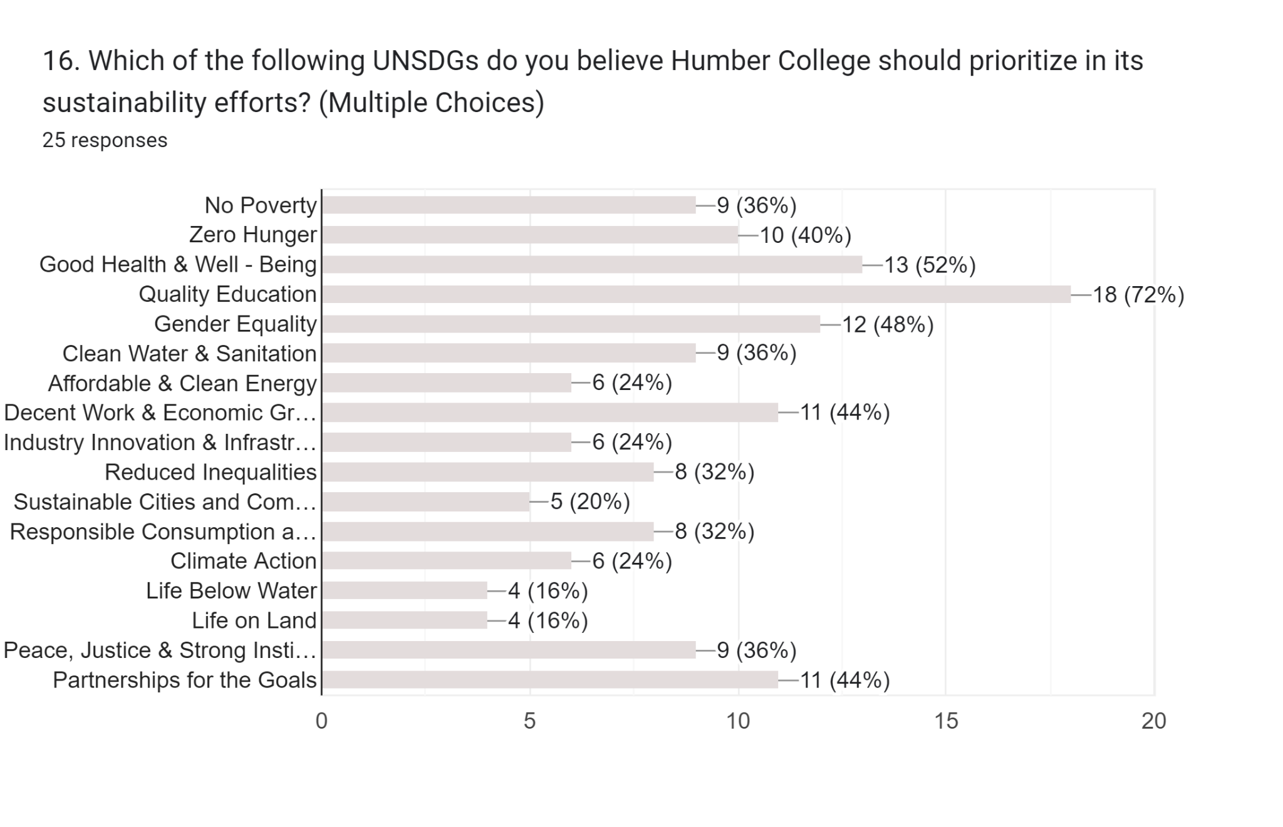

Forms response chart. Question title: 15. Which of the following UNSDGs do you believe Humber College should prioritize in its sustainability efforts? (Multiple Choices)
. Number of responses: 16 responses.

Forms response chart. Question title: 17. How do you think Humber College can further enhance its efforts in contributing to the achievement of the UN SDGs?
. Number of responses: 25 responses.

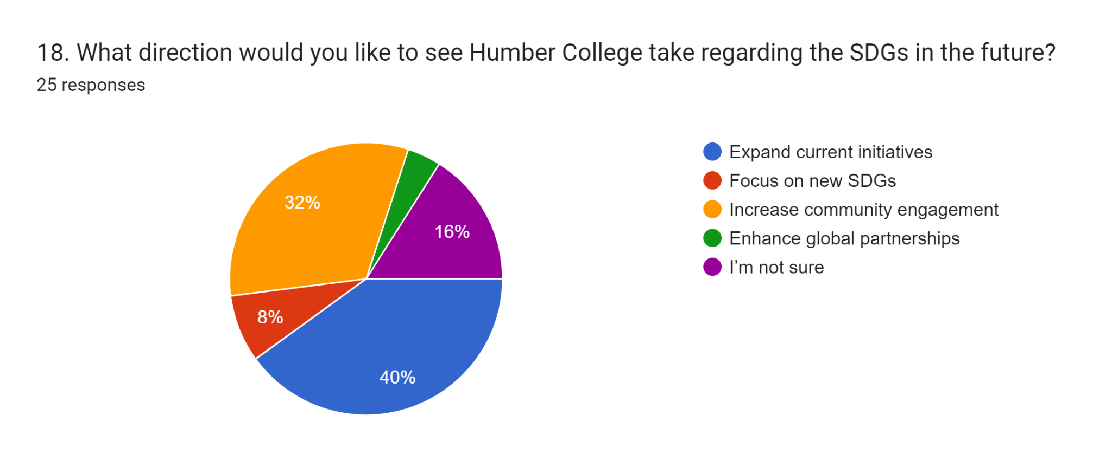

Forms response chart. Question title: 19. How would you rate your own personal commitment to sustainability and the principles of the UN SDGs?
. Number of responses: 25 responses.

Forms response chart. Question title: 20. Do you have any other suggestions for how Humber College can promote the SDGs?

. Number of responses: 25 responses.

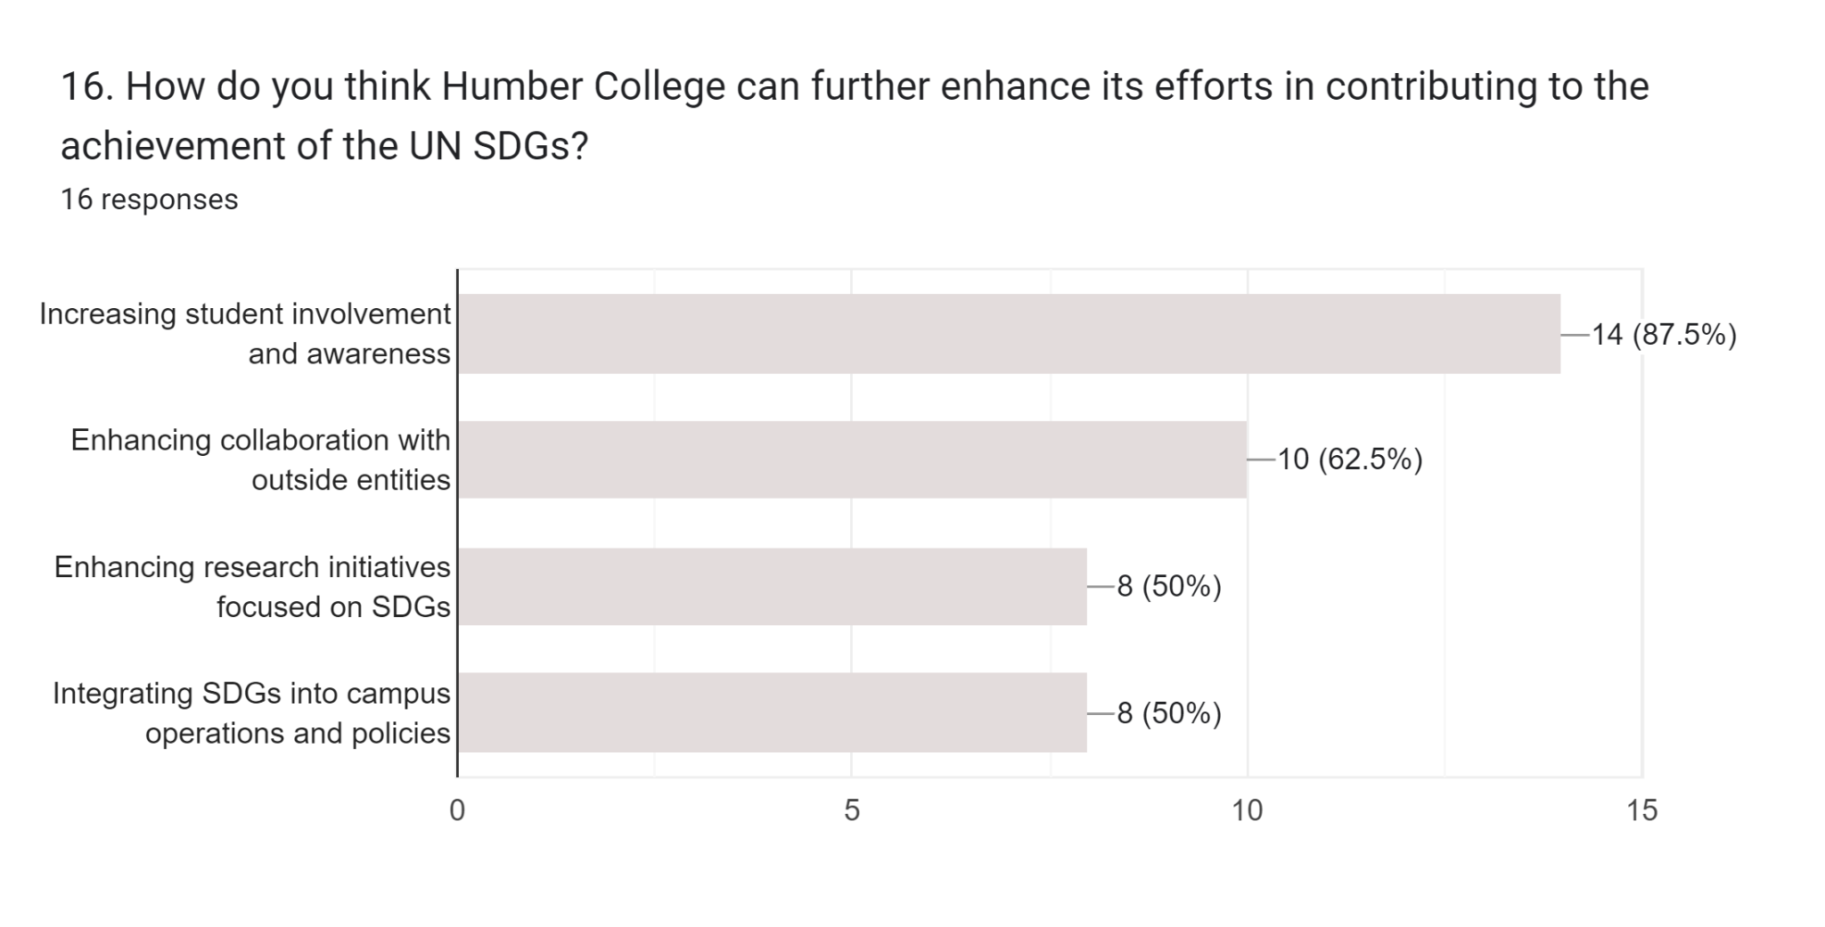

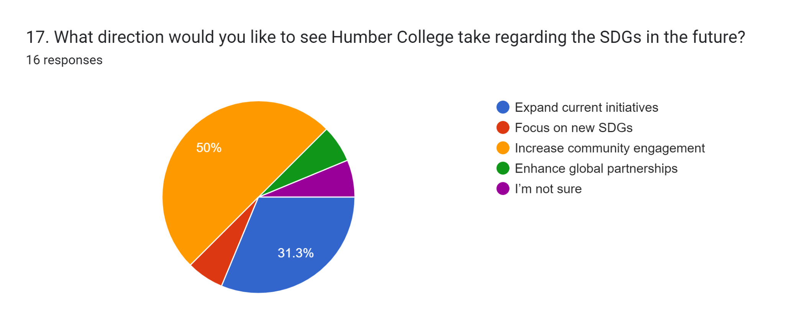

Forms response chart. Question title: 18. How would you rate your own personal commitment to sustainability and the principles of the UN SDGs?
. Number of responses: 16 responses.

Forms response chart. Question title: 19. Do you have any other suggestions for how Humber College can promote the SDGs?

. Number of responses: 16 responses.

**4.3 Interpretation of the results**

* **Awareness of U.N. SDGs:**
  + The majority of respondents are familiar with the United Nations Sustainable Development Goals (U.N. SDGs), indicating a good level of awareness among Humber College students.
* **Perception of Humber College's Contribution to U.N. SDGs:**
  + A significant portion of respondents believe that Humber College contributes to U.N. SDGs, suggesting that the college's initiatives are noticeable to some extent among the student body.
* **Participation in College-Organized Events related to U.N. SDGs:**
  + The data indicates that there is room for improvement in student participation in events or activities related to U.N. SDGs organized by the college.
* **Measurement of Impact at Humber College:**
  + While there's recognition of the need for comprehensive measurement systems, a substantial proportion of respondents believe that some measurement mechanisms already exist at Humber College to gauge its impact on U.N. SDGs.
* **Communication of Sustainability Initiatives at Humber College:**
  + There seems to be a varied perception of how effectively Humber College communicates its sustainability initiatives, with room for improvement noted by some respondents.
* **Ways to Encourage Student Engagement with SDGs at Humber College:**
  + The majority of respondents believe that offering a combination of sustainability-focused courses, workshops/guest lectures, and volunteer opportunities is the best approach to encourage student engagement with the SDGs.
* **Challenges Faced by Humber College in Aligning Activities with UN SDGs:**
  + Lack of awareness or understanding and resistance to change are perceived as significant challenges by some respondents, indicating areas where Humber College can focus its efforts.
* **Importance of Incorporating Sustainability Principles into Humber College's Operations:**
  + The majority of respondents consider it extremely important for Humber College to incorporate sustainability principles into all aspects of its operations.
* **Participation in Sustainability-Related Events at Humber College:**
  + There's interest among respondents in participating in sustainability-related events, suggesting potential for increased engagement if initiatives are tailored to student interests.
* **Effectiveness of Feedback Mechanisms for SDG-related Initiatives at Humber College:**
  + There's a mixed perception of the effectiveness of feedback mechanisms, indicating opportunities for improvement in this area.
* **Campus Culture Influence at Humber College by the SDGs:**
  + The data suggests that the SDGs have a notable influence on the campus culture at Humber College, with a significant proportion of respondents perceiving strong or very strong influence.
* **Awareness of SDG-related Initiatives at Humber College:**
  + While a majority of respondents have seen initiatives related to SDGs at Humber College, there's still a significant portion who haven't, indicating potential gaps in visibility.
* **Promotion of UN SDGs at Humber College:**
  + The data shows a varied extent of promotion for different SDGs at Humber College, suggesting opportunities for more consistent promotion across all goals.
* **Prioritization of SDGs by Respondents for Humber College:**
  + There's a diverse range of SDGs prioritized by respondents, indicating the need for a comprehensive approach to addressing various sustainability goals.
* **Enhancement Suggestions for Humber College Efforts towards UN SDGs:**
  + Respondents have provided valuable suggestions for enhancing Humber College's efforts towards achieving the UN SDGs, including increasing community engagement and integrating SDGs into campus policies.
* **Levels of Commitment towards Sustainability and UN SDGs:**
  + A majority of respondents express some level of commitment towards sustainability and the principles of the UN SDGs, with room for further engagement among some individuals.
* **Suggestions from Respondents:**
  + The data includes specific suggestions from respondents on how Humber College can enhance its sustainability initiatives, highlighting areas such as awareness-building, educational integration, and community engagement. These suggestions can serve as valuable insights for the college's sustainability strategy.

**4.4 Discussion of any Unexpected Results**

* Low awareness of the UN Sustainable Development Goals (SDGs) among Humber College students despite global efforts to promote them.
* A high level of perceived contribution by Humber College to the SDGs despite limited participation in college-organized events related to them.
* Divergent opinions on the effectiveness of communication regarding sustainability initiatives at Humber College.
* The prioritization of certain SDGs over others by respondents, which may not align with common expectations.
* Varied perceptions of the campus culture's influence by the SDGs, indicating a complex relationship between student attitudes and institutional practices.

These findings highlight opportunities for Humber College to bridge the gap between awareness and action and to ensure a more uniform approach to promoting all SDGs on campus.

**5. Discussion**

**5.1 Interpretation of the Results in light of the Literature Review**

Humber College has conducted research on its sustainable development plan based on the United Nations Sustainable Development Goals (UNSDGs). They have formulated an Integrated Energy Master Plan(IEMP) to address global energy and water challenges, emphasizing reducing carbon emissions and improving energy and water efficiency. The plan aims to achieve significant results through upgrading systems, implementing clean energy hubs, and establishing smart energy networks. By 2034, the investment required for these measures will be $66 million. The IEMP also supports academic initiatives, positioning Humber College as a center of excellence for comprehensive energy solutions. The progress of this plan will be continuously monitored through various indicators to ensure adjustments are made as needed. Through implementing the IEMP, Humber College aims to become a leader in energy and climate performance in Ontario and Canada.

**5.2 Discussion of the Implications of the Results for Practice and Future Research**

We have concluded several practical recommendations for Humber College in achieving the U.N. S.D.Gs:

Integrating Sustainable Development Goals (SDGs) into curriculum design: Incorporating SDGs into the curriculum design of institutions allows students to understand the importance, significance, and practical methods of these goals. Relevant courses or professional fields such as sustainable management, environmental science, and social innovation can be offered.

Launching research and practical projects: Establishing research or practical projects enables students and teachers to participate together in addressing local or global sustainable development issues. These projects could involve practical activities in community development, environmental protection, energy efficiency, and other areas.

Promoting social responsibility education: Advocating for students' awareness and practice of social responsibility through courses, lectures, seminars, etc. Encouraging students to participate in volunteer services, community services, and other activities nurtures their sense of concern for society and spirit of contribution.

We will also recommend further exploration in future research from the following multiple perspectives to contribute to providing a more comprehensive and in-depth understanding.

Future research areas in sustainability include:

Long-Term Impact Assessment: Evaluate Humber College’s Integrated Energy Master Plan (IEMP) over an extended period to gauge its effectiveness in achieving energy efficiency, carbon reduction, and economic goals.

Behavioral Interventions: Investigate methods to encourage stakeholders (students, faculty, staff) to actively participate in energy-saving behaviors and sustainable initiatives.

Circular Economy Implementation: Study the practical application of circular economy principles at Humber College to minimize waste, promote recycling, and close material loops.

Food Systems Resilience: Research ways to enhance the resilience of sustainable food systems, considering factors such as climate change adaptation, local sourcing, food security, and equitable access to nutritious food.

Innovative Financing Models: Explore various financing models like public-private partnerships, green bonds, and community investment mechanisms to fund sustainability projects like the IEMP.

Social Equity and Sustainability: Examine how sustainable practices can be inclusive, benefit marginalized communities, and address social justice issues.

Behavioral Economics: Apply principles of behavioral economics to encourage sustainable choices by understanding decision-making biases, nudges, and incentives.

Life Cycle Assessments (LCAs): Conduct comprehensive LCAs for campus activities to evaluate environmental impacts from inception to disposal.

Collaboration and Partnerships: Foster collaboration with institutions, industry partners, and government agencies to advance sustainability through joint research and knowledge sharing.

Education and Awareness: Develop educational programs and awareness campaigns to engage students, faculty, and the wider community in understanding sustainability concepts and their practical implications.

**5.3 Discussion of the Limitations of the Study and Suggestions for Future Research**

**Limitations of the study include:**

Causality: It may be difficult to establish a direct causal relationship between Humber College's contributions to the United Nations Sustainable Development Goals (SDGs) and its reputation or brand recognition. While the study may identify correlations, proving causality requires rigorous experimental designs or quasi-experimental methods.

Measurement Challenges: Objectively quantifying reputation and brand recognition presents complexities. Metrics such as university rankings, social media sentiment, or alumni surveys offer only partial insights. A comprehensive approach would entail triangulating data from multiple sources.

Context Dependency: The impact of SDG contributions on reputation varies depending on context. Factors like regional demographics, cultural perceptions, and industry partnerships influence stakeholders' perceptions of the college's efforts.

Time Frame: Building reputation is a gradual process. The study's short-term focus might not fully capture the cumulative effects of sustained SDG initiatives. Longitudinal studies are necessary to monitor changes over time.

**Areas for Future Research:**

Longitudinal Studies: Undertaking longitudinal research offers the opportunity to observe the dynamics of reputation over time. By annually monitoring Humber College's engagement with SDGs and reputation metrics, we can identify trends and evaluate the sustained impact.

Comparative Analysis: Conducting a comparative analysis between Humber College's SDG initiatives and those of similar institutions yields valuable insights. Investigate whether specific SDGs, such as climate action or quality education, have varying effects on enhancing reputation.

Stakeholder Perspectives: Qualitative research methods, such as interviews, focus groups, or surveys, can delve into stakeholder perceptions. Gathering input from students, faculty, alumni, employers, and community members provides nuanced insights into how SDG contributions are perceived.

Communication Strategies: Examining communication channels is essential. How does the college communicate information about its SDG initiatives? Understanding the role of effective storytelling, transparency, and alignment with stakeholder values ​​is crucial.

Sector-Wide Impact: Beyond Humber College, exploring the collective SDG efforts across educational institutions sheds light on the sector's reputation. Does collaboration amplify positive effects? Comparative studies across different countries may offer valuable insights into sector-wide impacts.

**5.4 Conclusion and Summary of the Key Findings and Implications**

The implications of the current study encompass several key areas:

Understanding Circular Economy and Sustainability: Recognizing the conceptual disparities between the circular economy and sustainability is vital. While the circular economy targets waste reduction, sustainability encompasses economic, social, and environmental equilibrium. Managers and policymakers must grasp their interconnected yet distinct roles.

Challenges in Sustainable Food Systems: Transitioning to sustainable food systems necessitates clear definitions and considerations of various sustainability dimensions. Stakeholder awareness and effective information dissemination are crucial. Policymakers and researchers must address sustainability, health, and consumer preference challenges.

Competitive Sustainability: Businesses should acknowledge that competitive sustainability significantly influences success. Although sustainability and innovation integration doesn't guarantee greater success, positioning sustainability as innovation enhances competitiveness. Grassroots entrepreneurs contribute to competitive sustainability, highlighting diverse motivations.

Industry Shifts and Entrepreneurial Risks: With industries moving towards sustainability, entrepreneurs encounter risks. Novel sustainable ventures may face challenges when established companies follow suit. Environmentalists should appreciate incumbents' efforts while fostering original entrepreneurs. Dynamic strategies and effective information dissemination are essential for sustaining a competitive advantage.

Holistic Approach: Integrating sustainability and circular economy principles requires a comprehensive approach. Businesses need to understand that sustainability encompasses social and economic dimensions besides the environmental aspect. A holistic understanding ensures informed decision-making.

Consumer Awareness: Despite consumer preferences for sustainable products, awareness remains a hurdle. Companies must bridge this gap by effectively communicating the sustainability aspects of their products. Educating consumers about the value of sustainable choices is imperative.

Strategic Positioning: Positioning sustainability as innovation enhances competitiveness. Companies should align sustainability efforts with market demands strategically. Recognizing sustainability as a competitive advantage motivates proactive adoption.

Dynamic Adaptation: Competitive sustainability demands continuous adaptation. Industry leaders must innovate continuously to stay ahead as competitors catch up. Flexibility and responsiveness are crucial for maintaining a sustainability advantage.

Stakeholder Engagement: Engaging stakeholders, both internal and external, is critical. Effective integration of sustainability requires collaboration among managers, policymakers, and researchers. Stakeholder awareness drives adoption and supports sustainable practices.

Balancing Objectives: Achieving a balance between sustainability and business success is essential. Entrepreneurs and established companies must navigate the tension between profitability and environmental impact. A nuanced approach considering diverse motivations and objectives is necessary.

Industry Leadership: Industry leaders play a pivotal role in driving sustainability. Their sustained commitment sets the tone for others, contributing to a broader shift towards responsible and resilient systems.

**6. References**

<https://www.britannica.com/science/sustainability>

# Colleges and Universities Should Strengthen Sustainability Education Programs by Increasing Interdisciplinarity, Fostering Experiential Learning, and Incorporating Diversity, Equity, and Inclusion(2020), National Academies - Sciences engineering Medicine. <https://www.nationalacademies.org/news/2020/10/colleges-and-universities-should-strengthen-sustainability-education-programs-by-increasing-interdisciplinarity-fostering-experiential-learning-and-incorporating-diversity-equity-and-inclusion>

# Daniel Thomas Mollenkamp(2023), What is Sustainability? How Sustainabilities Work, Benefits, and Example, Investopedia. <https://www.investopedia.com/terms/s/sustainability.asp>

Department of Economic and Social Affairs, Sustainable Department, United Nations. <https://sdgs.un.org/goals>

Humber’s Office of Sustainability, <https://humber.ca/sustainability/>

Global Summer Schoo (2024)l, Humber College. <https://humber.ca/global-opportunities/global-summer-school/non-humber-students-global-summer-school/courses/sustainability-essentials-building-a-greener-future.html>

Humber Annual Sustainability report(2020-2021), Humber’s office of sustainability. <https://humber.ca/sustainability/sites/default/files/2020-2021%20Humber%20Sustainability%20Report.pdf>

Humber Sustainability Supporting Actions 2019-2024(2019), Humber’s office of sustainability. <https://humber.ca/sustainability/sites/default/files/uploads/documents/HumberSustainabilitySupportingActions2019-2024.pdf>

https://humber.ca/sustainability/iemp

# Mainstreaming SDGs into College Curricula, Academic Impact, United Nations. https://www.un.org/en/academic-impact/mainstreaming-sdgs-college-curricula

**7. Appendices**

**7.1 Additional materials that support the analysis and findings, such as raw data, interview transcripts, or survey questionnaires.**

**List of Focus Group Questions:-**

Question 1: How has Humber impacted the Climate Action and Sustainable Cities and Communities goals in the college?

Question 2: Can you share a personal story or experience that reflects progress or challenges related to achieving Quality Education in your field of study at Humber College?

Question 3: In your opinion, what are the key factors influencing the success or failure of initiatives taken by Humber aimed at addressing Gender Equality?

Question 4: In your opinion, what are the key factors influencing the success or failure of initiatives taken by Humber aimed at addressing Reducing Inequality?

Question 5: How do you perceive the role of Humber College in contributing to the achievement of Zero Hunger & Good Health and Well-Being?

Question 6: In what ways have you observed collaboration or partnerships between different sectors (government, businesses, civil society) to address Goal Affordable and Clean Energy, Industry, Innovation and Infrastructure & Climate Action?

Question 7: Can you share examples of innovative approaches or grassroot efforts taken by Humber College that have influenced Clean Water and Sanitation outcomes?

Question 8: What changes or improvements do you envision in your college if No Poverty were successfully achieved?

Question 9: How can Humber College be better engaged in the pursuit of Responsible Consumption and Production to ensure a more inclusive and sustainable impact?

Question 10: Are there any challenges or barriers to integrating Decent Work and Economic Growth more fully into Humber College's activities? If so, what are they?

Question 11: In what ways does Humber College engage in the conservation of Life Below Water and Life on Land?.

Question 12: In what ways does Humber College address issues related to Peace, Justice and Strong Institutions and promote transparency and accountability?

Question 13: How do you see collaborations between Governments, Businesses, Civil Society Organizations at Humber College contributing to achievement of sustainable development?

**Transcript of Focus Group Discussions:-**

**Moderator**   
Hi, Everyone.  
OK.

**Moderator**   
So we have everyone.  
We'll quickly start now.  
Give me a minute.  
OK.  
There we go.  
So, good afternoon, everyone.  
Welcome to this insightful and engaging focus group.  
Discussion on the role of Humber College in relation to the United Nations Sustainable Development Goals.  
My name is Kunj and I'm thrilled to be your moderator for this session as we gather you to embark on a journey to explore the pivotal role that Humber College plays in contributing to the global agenda of sustainable development, as outlined by the United Nations.  
Today we have a diverse group of participants who share a common interest in understanding and evaluating humbug colleges.  
Impact on advancing these goals throughout our discussion, we will delve into various aspects from educational initiatives to community engagement, seeking to uncover the ways in which Humber aligns with and contributes to the UN SDGS.  
I encourage each of you to share your insights, experiences, and perspectives openly.  
A quick note before we start, we will be recording this meeting just for our reference and it will not be published anywhere.  
I hope that's OK with everyone.  
OK, the doubt.  
Further ado, let's begin.  
So question one, how has Humber impacted the climate action and sustainable cities and communities goals in the college?  
Uh, we can open the discussion to everyone or you all can just, you know, one by one, start giving in your insights.  
However, you guys wanna do it?  
OK.  
So should I just call out names one by one because then we can quickly take up this question.

**Person 1**   
I can try to answer if that's easier. Uh.

**Moderator**   
OK, perfect.  
Yeah, yeah, definitely.

**Person 1**   
I'm honestly not too sure how they have it.

**Moderator**   
Mm-hmm.

**Person 1**   
I would say within the college they like, try to promote sustainability through things like reusable water bottles and things like that.  
Felt the water stations.

**Moderator**   
Umm, sure.

**Person 1**   
So that's one way they've done that.

**Moderator**   
Anyone else guys?  
Is anyone aware of how Humber College is, you know, achieving these two goals or if anything, is there anything that you would like to add to that?

**Person 2**   
And I'd like to add that I saw some signs in the L building about sustainability, and I saw they have a little area for the bees.  
So I saw some of it, but I'm not too familiar with it other than that.

**Moderator**  
Umm.  
OK, perfect.  
Thanks for that, Person 3 and Person 4, do you guys have any inputs on this question or?

**Person 3**   
I've just seen posters around the college about sustainability and climate action, but I've not really seen them doing something about it or I have seen I've not participated yet in any of the activities yet, but I have for sure seen the same posters around the campus.

**Person 4**   
Go on.

**Moderator**   
OK, well.  
Sure.  
OK.  
Thank you for that.  
Moving on to question #2, can you share a personal story or an experience that reflects progress or challenges related to achieving quality education in your field of study at Humber College?  
Anyone experience or any progress or challenges that you faced at humble?

**Person 3**   
I feel the assignments that they try to give us is really a big part of that because it makes us go out and, you know, relate everything that we study with the, the topics or the things that go goes on in the market, especially with the finance that the thing between that we're doing right now.

**Moderator**   
Me.  
Right.

**Person 3**   
So things like that, it really helps to understand the whole topic and everything, which I believe is a good thing or related to that aspect.

**Moderator**   
Ohh, perfect.  
Thank you.  
Anyone else guys?

**Person 4**   
Uh, yeah, I would like to add and as well as suggest, I guess, yeah, the assignment specifically that we're getting especially in this project that we're doing this course.

**Moderator**   
Umm.

**Person 4**   
So we will do a lot of group assignments so we get a chance to actually experience what's gonna happen in the outside world, will be put to it here.

**Moderator**   
Mm-hmm. Yeah.  
Right.

**Person 4**   
So we'll be working with people from different countries.  
They have different ideologies, but we have to work on the same thing.  
So when we are collaborating with people of different experiences, it gives us a chance to grow to a different horizon all together.  
So I guess that that's a great thing. And Humber College.  
Yeah.

**Moderator**   
Perfect.

**Person 4**   
And the real project, yeah.

**Moderator**   
Thank you.  
Yeah.  
Perfect.  
Thank you.  
Anyone else guys?  
Or should we move ahead?  
OK, I'll move forward.  
So, in your opinion, what are the key factors influencing the success or failure of initiatives taken by Humber aimed at addressing gender equality?

**Person 1**   
Umm the 16 access I would say for gender equality is in all the bathrooms.

**Moderator**   
Umm.

**Person 1**   
They make it really well known that most, like some of them, are gender neutral and their signs in the bathroom saying if you don't like, appreciate someone's gender in here, then just keep it to yourself.  
They, like, try to promote inclusivity.

**Moderator**   
Perfect.  
Yeah, that's really great.  
Anyone else guys?

**Person 4**   
Yes.  
So I would like to add to this.  
Uh, in my previous course I really liked the fact, like when there was, uh, introductions going on, all of my professors, they specially took this, you know, initiative.

**Moderator**   
Umm.  
Mm-hmm.

**Person 4**   
And they asked every student during the introduction how they would like to be addressed like, you know, and everybody was like, they were making this a point that they use.

**Moderator**   
Yeah.

**Person 4**   
They were adding the pronouns that they would like to address within the introduction itself.

**Moderator**   
Umm.

**Person 4**   
It's not just to give clarity to the professor, but also to the other students.  
So I really liked that.  
It's not as humber as the whole works in that sense that all the professors, the departments like she mentioned, washroom.  
So like every nook and corner, they're keeping these small, small points and consideration.  
So I'd really like that idea about Humber..

**Moderator**   
Right.  
OK, perfect.  
Thank you so much.  
Anyone else guys.

**Person 3**   
Uh, yeah.  
They also have a proper, uh LGBTQ plus Resource Center in the college campus, and that's, like, fully developed.

**Moderator**   
Yes, yes.

**Person 3**   
They do a lot of activities and a lot of local stuff that they do every single day, and you can go there and get some therapy or help the community, reset or stuff like that only or even meet something that's really good.  
I don't think most of the colleges have that, or even if they do, they don't really have like of that size as I've seen in Humber yet.

**Moderator**   
Yeah.  
Yeah.  
So Humber is very serious in, you know, handling these departments and situations.  
You're right.  
Thank you for that.  
Moving on.  
Question 4 In your opinion, what are the key factors influencing the success or failure of initiatives taken by Humber aimed at addressing reducing inequality?  
So you all can take this question, anyone.

**Person 2**   
I've noticed that in the classes the lecturers are often aware that there is a lot of diversity in the classroom and they usually use that as a positive thing like to get different perspectives and opinions.  
About different places and I found that to be interesting.

**Moderator**   
Umm. Yes. Perfect.  
Thank you, anyone else.

**Group Member**   
I also think that in relation to our classes' studies, the research that we do, they tend to give us the opportunity to relate back to where we're from or to search things relating to what we're familiar with and share it with the class.  
So it gives everyone exposure to understand each point of view as well.

**Moderator**   
Correct.  
Thank you, Group Member.  
Anyone else would like to add at this point?  
OK.  
Moving forward, Question 5, how do you perceive the role of Humber College in contributing to the achievement of 0 hunger and good health and well being?  
Mm-hmm.

**Person 3**   
Related to community management, all that has been good.

**Moderator**   
Right.

**Person 3**   
I recently found out that they gave out free soups to students.  
Uh, like there's a fridge and the building.

**Moderator**   
Right.

**Person 3**   
I saw that they also have proper taffetas, although there are a whole lot of healthy options in it.

**Moderator**   
Yeah.

**Person 3**   
Well, on the top floor, I'm guessing and I.

**Moderator**   
Umm.

**Person 3**   
Yeah, that's what I feel that they try to do or even they hand out like a whole lot of free stuff to students who might be in need have seen them doing that quite a few times.

**Moderator**   
Thanks.  
Thank you so much for that point.  
Also Humber I believe is you know has provided us all international students with insurance like health and dental as well.

**Person 3**   
Yeah, yeah, that is well.

**Moderator**   
So yeah.  
Yes.  
So even that is a very good point.  
That number is taken care of and is covered within our curriculum.  
So thank you, Person 3.

**Person 3**   
But I guess.

**Moderator**   
Thank you for that point.  
Yeah, I'm sorry.

**Person 4**   
Ohh.

**Person 3**   
Yeah, but I guess everyone.

**Moderator**   
You were saying something?

**Person 3**   
Yeah, everyone has to do that.  
Actually, it's like a legal requirement that you have to provide insurance.  
But what I do feel that's good on their behalf is that they have a doctor or like a clinic on the campus, which not all colleges have.

**Moderator**   
Right.  
Hmm, right.  
Right. Perfect.  
Thank you.  
Anyone else would like to add? Yeah.

**Person 4**   
And yeah, I would like to add one point here.

**Moderator**   
Umm.

**Person 4**   
Uh, it's about the mental Wellness.  
So Humber a check keeps you track of that also.

**Moderator**   
Umm.

Like they know that the overall development is required, so if there's any store and you know who struggles.  
So Humber has their Wellness Center.  
So where they have people who can help, students who are going through any mental problems, like they're finding it hard to, you know, cope with these situations.  
And also I find what is like a very creative part is like there are sleeping lounges so they know there's two.

**Moderator**  
No.  
Yeah.

**Person 4**   
That's where traveling.  
They know that students are very packed, scheduled.  
So I guess that is also a very creative idea.

**Moderator**  
Umm.  
Yeah. Perfect.

**Person 4**   
So I like that a lot of colleges and universities have this.  
But Humber has this.  
So I really like this about it.

**Moderator**   
Thank you.  
That was a great point, Person 4.  
OK.  
Moving forward, question 6, what ways have you observed collaboration or partnerships between different sectors?  
May be government businesses, civil society to address affordable and clean energy, industry, innovation and infrastructure.  
So like if you know about any of these, you all can say them to us.

**Person 3**   
Umm like I read about it somewhere in some of the ohh sorry.

**Group Member**   
Ohh.  
Ohh no car out after.

**Person 3**   
Like they know that the overall development is required, so if there's any store and you know who struggles.  
So Humber has their Wellness Center.  
So where they have people who can help, students who are going through any mental problems, like they're finding it hard to, you know, cope with these situations.  
And also I find what is like a very creative part is like there are sleeping lounges so they know there's two.

**Moderator**   
No.  
Yeah.

**Person 4**   
That's when traveling.  
They know that students are very packed, scheduled.  
So I guess that is also a very creative idea.

**Moderator**   
Umm.  
Yeah. Perfect.

**Person 4**   
So I like that a lot of colleges and universities have this.  
But Humber has this.  
So I really like this about it.

**Moderator**   
Thank you.  
That was a great point, Person 4.  
OK.  
Moving forward, question 6, what ways have you observed collaboration or partnerships between different sectors?  
May be government businesses, civil society to address affordable and clean energy, industry, innovation and infrastructure.  
So like if you know about any of these, you all can say them to us.

**Person 3**   
Umm like I read about it somewhere in some of the ohh sorry.

**Group Member**   
Ohh.  
Ohh no car out after.

**Person 3**   
Was really insightful moving forward to question seven.  
Can you share examples of innovative approaches or grassroot efforts taken by Humber College that have influenced clean water and sanitation outcomes?  
If you've experienced any of them, or do you see any of them in your regular classes?

**Person 1**   
For the approaches to sanitation, I know in the bathrooms they have a QR code where you can scan and then let the like campus know that a bathroom needs a product or it's cleaning or something which I haven't seen ever before.

**Moderator**   
Umm.  
Umm.  
Oh yeah, even I've seen that in.  
That's really good.  
That's a good point.

**Person 1**   
Umm.

**Moderator**   
Anyone else guys?  
Group Member.  
Are you trying to say something you're in?

**Group Member**   
Ohh no sorry, forgot to unmute.

**Moderator**   
Yeah, no worries.  
No worries.  
No worries.  
OK, then moving forward.  
So what changes or improvements do you envision in your college if no poverty was successfully achieved?  
We can have a good discussion on this.

**Group Member**   
Can I ask if you can elaborate on the question a bit more just to?

**Moderator**   
Yeah, definitely.

**Group Member**   
Can you elaborate on the question a bit more?

**Moderator**   
Ohk.  
OK, so basically what we are trying to achieve here right now is that you know there are these basic 17 goals that you and have published for everyone to, you know kind of take on and I'll be a part of and how you can use it in your organization or you know your culture.  
So basically what we're trying to do is we're trying to research on how Humber as a college is trying to achieve these seventeen goals, are they even touching on all the goals are they or so we've researched.

**Group Member**   
Yeah.  
No.  
Stop.  
Stop that part.  
I'm just asking if you can elaborate the question a bit more.

**Moderator**   
Yeah.  
So.  
So basically what we were researching for during, you know, to make the questionnaire or for the focus group research, that number has not really touched much about no poverty on this goal specifically.  
So we've included this question to see if you know Humber kind of includes this point in their whole agenda and how can we better achieve this goal as students together.  
So that's a point that we wanted to clarify.

**Group Member**   
OK, understood.  
Thank you.

**Moderator**   
Yeah.

**Person 3**   
As a caller, I've not seen a full body.

**Moderator**   
Mm-hmm. Right.

**Person 3**   
Scholarships on their website.  
What they have is like 500 dollars, $2000 or $5000 in maximum which are very specific to some of the courses and I'm not even from them.

**Moderator**   
Right.

**Person 3**   
They're coming from like other sources.  
So as a college, they are not doing much by themselves to provide, you know, scholarships to students, especially international ones.

**Moderator**   
Umm.  
Right.

**Person 3**   
They haven't explored international students.  
I guess we can only apply for a $500.00 one and there is another thousand or $2000 one which I saw before and they're not really not doing much on that part.

**Moderator**   
Right.

**Person 3**   
I I believe because most of not the colleges, but the universities I know, do 100% scholarships and it could, like it, could go up to 100% scholarships.  
So I don't think they are doing that, which I think they should work on.

**Moderator**   
Yes.  
OK, perfect.  
Thank you for that point, Person 3.  
Also, while we were doing this project, we were very in close touch with the Sustainable Department of Humber College and you know we are kind of getting more information on how they are promoting things and how they are achieving these goals.  
So we will definitely, we are going to speak to them about how they can, you know, take more efforts and or towards contributing to this goal, especially as students you know you kind of need a lot of scholarships.  
But thank you for addressing that.

**Person 3**   
Nice.

**Moderator**   
OK, moving forward.

**Person 2**   
Umm, I would say.

**Moderator**   
Yeah.  
Sorry you can.

**Person 2**   
And I would also say it's good that they include the career development course really early on to get us prepared for applying and job searching.

**Moderator**   
Umm.

**Person 2**   
It would be nice though, if they also had a more involved part in the placements, and that internships and anything that they provide, if they had a way to have, I don't know.

**Moderator**   
Right.  
Exactly.

**Person 2**   
I think sometimes the professors or the instructors will have the opportunities that they know about or if there was just a better way to communicate the opportunities and now they have a system.  
But it's all kind of like doing it yourself.  
I think maybe that I don't know if the career course it's gonna go into that more, but it would be nice if they yeah had that as a bigger part.

**Moderator**   
Yes.  
Completely agree with you.  
Very good point.  
Thank you for that.  
OK.  
Then moving forward.  
So question 9 is how can Humber College be better engaged in the pursuit of responsible consumption and production to ensure more inclusive and sustainable impact?  
Anything that you guys have seen or you suggest that Humber can take up?

**Person 2**   
I haven't seen any composting on campus.  
I'm not sure if I'm wrong, but I didn't see it, so if they don't have that that would be a good thing to do.

**Moderator**   
Umm.  
OK.  
Perfect.  
Anyone else guys?

**Person 3**   
And then most of the times when I've seen big universities or colleges like this is a huge campus, they have like automatic turn offs on their lights.

**Moderator**   
Mm-hmm.

**Person 3**   
Most of us most of the time, what I've seen is if the whole building there is no class going on, still the lights are on and like it's, I don't find that to be good actually.

**Moderator**   
OK.

**Person 3**   
And you should have some stick stuff in it like which turns it off when no one is using something, right?

**Moderator**   
Yeah.  
Yeah.  
Yeah, that's a great point.  
Even I didn't notice it, but now that you say it, I kind of recall that.  
Yeah, that's happening.  
And I call it.  
Thanks for that point.  
OK, moving forward.  
Are there any challenges or barriers to integrating decent work and economic growth more fully into Humber colleges activities?  
If so, what are they?  
If anything that you feel or you know, you might have seen, you can elaborate on this point.  
I think this, uh, kind of matches with what just happened a few minutes before of having like, you know, just having a good career department where, you know, they're kind of help students getting into their first internship or a first job.  
Which kind of then you know, helps them grow economically and also get a decent job after college.

**Person 3**   
They do have that, but I think they don't advertise it much.  
Actually, that's what they are failing to do here.  
Historians don't really know about it.  
There is a whole department just for this to help students with jobs and everything, but again, not everyone knows about it.

**Moderator**   
Mm-hmm.  
Ohh OK, perfect.  
Thank you.  
Anyone else would like to add to this goal guys?  
OK, perfect.  
No worries.  
Let's move forward.  
So in what ways does Humber College engage in the conservation of life below water and life on land?  
If you've seen anything in the college you've read anything about it you all can discuss it with us.

**Person 2**   
I mean, I'll bring up these things again.  
They had this little area, like a balcony that was closed off and it was an area just for them.

**Moderator**   
Mm-hmm.

**Person 2**   
So I thought that was really cute.

**Moderator**   
No.  
OK.  
Thank you.  
Anyone else guys?  
Buffett moving forward, I think this is going to be our last question.  
So in what ways does Humber College address issues related to peace, justice, and strong institutions and promote transparency and accountability?

**Person 1**   
I think Humber, like just with all their like advertisements around the school and stuff, it's all about, like inclusivity and kind of just being nice to one another.

**Moderator**   
Mm-hmm.

**Person 1**   
So that's one way they promote peace and stuff and transparency at the school.

**Moderator**   
Right.  
OK.  
Thank you.  
Anyone else guys?

**Person 4**   
Yeah.  
So I would like to add to the accountability point, like from my experience, I guess in the first tier like I did two, I'm doing my second program.

**Moderator**   
Mm-hmm.

**Person 4**   
So during the first program on, even during the second program, as we all know like we international students, we are usually impacted.

**Moderator**   
Right.

**Person 4**   
If there's anything, any new rules that are coming in the immigration right, so as soon as IRCC announces any news that's related to any college.

**Moderator**   
Yes.  
Mm-hmm.

**Person 4**   
So we're college, actually.  
Make sure that in a day or even before you know, within that 24 hours of bracket, they send information directly through emails to the students.  
You know that they need not to panic in any way because you know how much students are gonna be impacted by this rule.

**Moderator**   
Mm-hmm.

**Person 4**   
So I feel that gives you a sense of relief.

**Moderator**   
Rank.

**Person 4**   
It gives me a sense of relief because I am sure that you know, this rule is not impacting me or my study here in Canada in any manner.  
So I feel that's a great thing and they're really answerable towards the students.  
And they also conduct a lot of sessions on a timely basis.  
So that if students have any confusion related to what's happening in the immigration, they can attend that and they can get clarity on that.  
So that's why I will say kudos to Humber for doing that.

**Moderator**   
That's a brilliant point.  
Thanks Sooja for that and I think this is the last question, sorry for that.  
So how do you see collaborations between governments, businesses, civil society organizations at Humber College contributing to achievement of sustainable development?  
I think we've pretty much covered this point before where you guys have all discussed how Humber collaborates with the different government organizations.  
But if you would like to add to any not a problem.  
Anyone, guys?  
OK, perfect.  
So problem.  
So thank you.  
Thank you everyone for your time, openness and collaboration in the coming days, we will analyze the data gathered today and incorporate these insights into our plans and strategies for the project.  
Further, your input is integral to our success and we look forward to keeping you all updated on the progress that we have made as a result of our collective efforts today.  
If you have any further questions or comments, please don't hesitate to reach out to us.  
Thank you once again and have a wonderful day before you guys all leave as a small token of appreciation, kindly let us know what coffee would you like, or you know what is this coffee that you like from a specific shop or a specific store?  
And the next time we meet, we would just like to, you know, hand out coffee for all of you.  
And as our professor says, the best tasting coffee is always free coffee.  
So please don't hesitate and definitely reach out to us and let us know what coffees would you like to have.

**Person 1**   
Thank you.

**Moderator**   
Thank you.  
Thank you everyone.

**Person 3**   
Thank you.

**Person 1**   
Thanks. Thanks.

**Person 3**   
Yeah.

**Person 3**   
Bye, bye.

**Person 2**   
You.

**Moderator**   
Thank you.  
Thank you everyone.  
Have a wonderful day.

**Person 4**   
Bye guys.

**Moderator**   
Bye.

**Moderator**   
Yeah, I did expect like, not people knowing a lot about it.  
So, but still there were a lot of good inputs like.

**List of Survey Questions:-**

1. How familiar are you with the concept of UN Sustainable Development Goals (SDGs)?

* Very familiar
* Somewhat familiar
* Not Familiar

2. What does “SDGs” stand for, and how many SDGs are there in total?

* Sustainable Development Goals; 17
* Social Development Goals; 10
* Sustainable Development Goals; 10
* Social Development Goals; 17

3. Do you think Humber College contributes to the accomplishment of the U.N. Sustainable Development Goals?

* Strongly agree
* Agree
* Neutral
* Disagree
* Strongly disagree

4. Have you participated in any activities or events organized by the college that promote awareness of the UNSDGs?

* Yes, regularly participate
* Yes, occasionally participate
* No participation

5. Have you received any education or training on the UNSDGs during your time at the college?

* Yes, extensively
* Yes, to some extent
* No

6. How do you think the college measures its impact and progress towards achieving the UNSDGs?

* Comprehensive measurement systems in place
* Some measurement mechanisms exist
* No clear measurement approach

7. In your opinion, how effectively does Humber College communicate its sustainability initiatives to students, staff, and the wider community?

a) Very effectively

b) Moderately effectively

c) Slightly effectively

d) Not effectively at all

8. In your opinion, what is the best way for Humber College to encourage student engagement with the SDGs?

* Offer more sustainability-focused courses and programs.
* Organize workshops and guest lectures.
* Provide volunteer opportunities related to the SDGs.
* All of the above

9. What challenges do you think Humber College might face in aligning its activities with the UN SDGs?

* Lack of resources
* Resistance to change
* Lack of awareness or understanding
* Institutional barriers

10. How important do you think it is for educational institutions like Humber College to incorporate sustainability principles into all aspects of their operations?

* Extremely important
* Very important
* Somewhat important
* Not important at all

11. Have you personally participated in any sustainability-related events or activities organized by Humber College?

* Yes, multiple times
* Yes, once
* No, but I would be interested
* No, and I am not interested

12. Have you ever seen any initiatives at Humber College related to the SDGs?

* Yes
* No
* Unsure

13. If you answered yes to the question asked above, which of the following SDGs have you seen promoted at Humber? (Select all that apply)

* Decent Work and Economic Growth (SDG 8)
* Gender Equality (SDG 5)
* Responsible Consumption and Production (SDG 12)
* None of the above

14. How effective are the feedback mechanisms for SDG-related initiatives at Humber College?

* Very effective
* Effective
* Somewhat effective
* Not very effective
* Not effective at all

15. How strongly is the campus culture at Humber College influenced by the SDGs?

* Very strongly
* Strongly
* Moderately
* Weakly
* Not at all

16. Which of the following UNSDGs do you believe Humber College should prioritize in its sustainability efforts? (Multiple Choices)

1. No Poverty
2. Zero Hunger
3. Good Health & Well - Being
4. Quality Education
5. Gender Equality
6. Clean Water & Sanitation
7. Affordable & Clean Energy
8. Decent Work & Economic Growth
9. Industry Innovation & Infrastructure
10. Reduced Inequalities
11. Sustainable Cities and Communities
12. Responsible Consumption and Production
13. Climate Action
14. Life Below Water
15. Life on Land
16. Peace, Justice & Strong Institutions
17. Partnerships for the Goals

17. How do you think Humber College can further enhance its efforts in contributing to the achievement of the UN SDGs?

* Increasing student involvement and awareness
* Strengthening partnerships with external organizations
* Enhancing research initiatives focused on SDGs
* Integrating SDGs into campus operations and policies

18. What direction would you like to see Humber College take regarding the SDGs in the future?

* Expand current initiatives
* Focus on new SDGs
* Increase community engagement
* Enhance global partnerships
* I’m not sure

19. How would you rate your own personal commitment to sustainability and the principles of the UN SDGs?

* Very Committed
* Somewhat Committed
* Not Committed at all

20. Do you have any other suggestions for how Humber College can promote the SDGs?

* No
* Yes ___________

**7.2 Assignments**

**ASSIGNMENT 2**

**Research Top / Problem / Opportunity**

**Topic Selection**

What is your topic? Write 3 topics and only 1 will be approved by your instructor:

| Role of Humber college in relation to UNSDGs. |
| --- |

**The Research Question**

List all your questions below:

| **Secondary Research Questions:-**   1. Which goals related to U.N. S.D.G. focused by Humber College? 2. What is the role of Humber College in the U.N. S.D.G. Goals? 3. What are the action plans of Humber College to achieve the goals? 4. How will Humber College achieve these goals? 5. Who will benefit after achieving the goals? 6. What is the role of Humber College in Quality Education? 7. What is International Learning Outcome (ILO) & Humber Learning Outcome (HLO)? 8. How do ILO & HLO play a significant role in Quality Education? 9. What are sustainability courses and programs at Humber College? 10. What is the role of Humber College in Gender Equality? 11. Does Humber College take any necessary actions in case of Gender Inequality? 12. What are the policies to maintain Gender Equality? 13. How is Humber College playing a role in Clean Water & Sanitation? 14. What are the initiatives taken by the college in Clean Water & Sanitation? 15. How do water refill stations play a role in Clean Water & Sanitation? 16. How many plastic water bottles are avoided through water refill stations? 17. What is Humber's overall framework regarding affordable and clean energy? 18. What are some figures showing Humber’s position on affordable and clean energy? 19. What steps has Humber fulfilled relating to sustainability? 20. What Funds has Humber received in relation to sustainable transportation? 21. What does the UN SDG’s goals emphasized on? 22. Which sector of the population will be affected by the fulfillment of these goals? 23. Is there something Humber did for the students/people during the covid period by providing them good food and sanitation? 24. What is the basic concept of Humber for achieving zero hunger? 25. What are the facilities that Humber provides its students to save them from Hunger? 26. Does Humber participate in any of the food challenges for supporting zero Hunger? 27. What is the contribution of Humber in the third goal of UN SDG’s? 28. What are the food and sustainability services provided by Humber college? 29. What are the sustainability programs and learnings provided by the college? 30. Who all are trained to prepare food and why? 31. What are the medical facilities that Humber provides to its students and how much do they charge for that? 32. Is Humber selling their food products at an affordable price or not? 33. Who all are the target audience for the college? 34. To what extent does Humber College incorporate the principles and objectives of the United Nations SDGs into its sustainability initiatives? 35. How does Humber College's sustainability strategy align with specific SDGs, and which goals have been prioritized in its approach? 36. What are the key sustainability initiatives and projects undertaken by Humber College that directly contribute to the achievement of specific SDGs? 37. How does Humber College measure and track its sustainability impact in relation to the SDGs? What metrics and indicators are used to evaluate progress? 38. What are the perceived strengths and successes of Humber College's sustainability initiatives in relation to the SDGs? How have these initiatives been received by the college community and external stakeholders? |
| --- |

**Keywords / Concepts**

What keyword searches are you using? This will help you find relevant peer-reviewed journal articles from the library:

| Quality Education, Sustainability, Water Sanitation, Service Quality, economic growth, climate action, affordable energy, No Poverty, Zero Hunger, Sustainability, Food for all, Good life and wellbeing, medical facilities, sanitation, Integration, Reduced Inequalities, Sustainability, Green technology, Climate Action,Social Equity, Sustainable Transportation, Community Education |
| --- |

**Journal Articles** (from Humber Library)

Find **4 peer-reviewed** journal articles that support and explore your research question

| Article Title: | In search of quality: measuring Higher Education Service Quality |
| --- | --- |
| Why do you like this article? | Because it talks about the sustainability on quality education and what are the measures needs to be taken to enhance the quality of educations in the Global market |
| APA citation for Article: | Khawaja Fawad Latif, Imran Latif, Umar Farooq Sahibzada and Mohsin Ullah (2019), In search of quality: measuring Higher Education Service Quality (HiEduQual). <https://www.tandfonline.com/doi/full/10.1080/14783363.2017.1338133> |
|  |  |

| Article Title: | Competitive Sustainability: The Intersection of Sustainability and Business Success |
| --- | --- |
| Why do you like this article? | It talks about sustainability in businesses and how it should be competitive advantage. Also, a glimpse into future of sustainability in the business world. |
| APA citation for Article: | [Clyde Eiríkur Hull](https://go-gale-com.ezproxy.humber.ca/ps/advancedSearch.do?method=doSearch&searchType=AdvancedSearchForm&searchMethod=subject+click&userGroupName=humber&inputFieldNames%5b0%5d=AU&prodId=AONE&inputFieldValues%5b0%5d=%22Clyde+Eir%C3%ADkur+Hull%22) (2022), Competitive Sustainability: The Intersection of Sustainability and Business Success. [Sustainability](https://go-gale-com.ezproxy.humber.ca/ps/aboutJournal.do?contentModuleId=AONE&resultClickType=AboutThisPublication&actionString=DO_DISPLAY_ABOUT_PAGE&searchType=AdvancedSearchForm&docId=GALE%7C5TRZ&userGroupName=humber&inPS=true&rcDocId=GALE%7CA746688415&prodId=AONE&pubDate=120221201)(Vol. 14, Issue 24). <http://dx.doi.org.ezproxy.humber.ca/10.3390/su142416420> |
| Name: | Diksha Sharma |

| Article Title: | Circular Economy; Sustainability |
| --- | --- |
| Why do you like this article? | It focuses on differences as well as similarities between circular economy and sustainability,environmental problems, and emphasizes on societal expectations and why they are in decline. |
| APA citation for Article: | Martin, G., Paulo, S., Nancy, B, & Erik J.H. (2017, February 1). *The Circular Economy: A new sustainability paradigm?.* Science Direct.  <https://www-sciencedirect-com.ezproxy.humber.ca/science/article/pii/S0959652616321023?via%3Dihub> |
| Name | Moyo Ogunyanwo |

| Article Title: | When food systems meet sustainability – Current narratives and implications for actions |
| --- | --- |
| Why do you like this article? | The aspect I found interesting in this case is that it includes an approach of Sustainable food system, and discusses more in depth about the challenges and obstacles that are faced while interacting with the food system. Moreover, there are different issues discussed, which describes the challenges properly. |
| APA citation for Article: | Christophe, B ., Peter, O., Lea, L., & Inge D. B. (2019, January). *When food systems meet sustainability – Current narratives and implications for actions.* Science Direct.  *https://www-sciencedirect-com.ezproxy.humber.ca/science/article/pii/S0305750X18303115?via%3Dihub#section-cited-by* |
| Name | Vrinda v sharma |

**Introduction**

Who is the client? What decision(s) do they need to make? What is the relevant information reader needs to understand the problem?

Client is Humber College. Based on this report, they need to understand the gap of understanding among the students in relation to the Role of Humber College towards U.N. S.D.Gs.

**Situational Analysis**:

Include a brief business environment scan (PESTED+C) and first draft of a SWOT analysis.

External Scan (include only things that are relevant)

➢ Political / Legal

➢ Economic

➢ Social / Cultural

➢ Technology

➢ Ecological

➢ Demographic

➢ Competition

**Research Problem / Opportunity**

**By working towards SDGs, Humber college enhances its reputation.**

**Hypothesis -** If Humber college contributes towards U.N. S.D.Gs, then it will increase its reputation and brand recognition

**Research Objective (s):**

1. Evaluate how well Humber College’s initiatives align with specific UNSDGs. Investigate the effects of these efforts on campus sustainability, student learning, and community engagement.
2. Explore the incorporation of UNSDGs into academic programs and courses. Assess the effectiveness of teaching methods and materials related to sustainability and global challenges.
3. Investigate how different stakeholders (students, faculty, staff, community partners) perceive and participate in UN SDG-related activities. Understand their motivations, barriers, and awareness levels.
4. Identify successful practices, innovations, and case studies within Humber College that contribute to UNSDGs. Highlight examples of sustainable campus operations, student-led initiatives, and community partnerships.
5. Examine obstacles faced by Humber College in advancing UNSDGs. Consider financial constraints, institutional policies, and cultural factors that may impede progress.
6. Develop evidence-based recommendations to enhance Humber’s commitment to UNSDGs. Propose strategies for scaling up existing efforts and addressing gaps.

**Schedule / Plan**

| **Week** | **What Needs to Be Done** | **Due Date** | **Who is responsible** | **Note** |
| --- | --- | --- | --- | --- |
| 3rd | Assignment 2: Research Problem | Feb 17th 2024 | Team Research Squad |  |
| 3rd | Assignment 3: Focus Group Outline | March 16th 2024 | Team Research Squad |  |
| 4th | Assignment 4: Research Questionnaire | March 23rd 2024 | Team Research Squad |  |
| 1st | Assignment 5: Written Report | April 4th 2024 | Team Research Squad |  |
| 2nd | Assignment 6: Marketing Research Final Research Project Presentation | April 11th 2024 | Team Research Squad |  |
| **Group Presentation** |  | April 11th 2024 | Team Research Squad |  |

Focus Group Assignment 3

**Role of Humber college in relation to U.N. S.D.Gs**

Focus Group sample : Humber College Students

**Group Members**

Diksha Sharma - N01661832

Krupal Vaghela - N01655862

Kunj Joshi - N01658854

Moyosola Ogunyanwo - N01650025

Vrinda Sharma - N01643228

Anson Xie Weiwei - N01622389

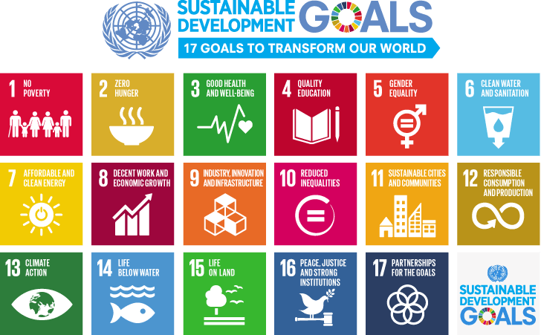

**Focus Group Outline**

**Moderator Introduction**

Good Afternoon everyone, welcome to this insightful and engaging focus group discussion on the role of Humber College in relation to the United Nations Sustainable Development Goals. My name is Kunj and I am thrilled to be your moderator for this focus group session.

As we gather here we embark on a journey to explore the pivotal role that Humber College plays in contributing to the global agenda of Sustainable development as outlined by the United Nations.

Today, we have a diverse group of participants who share a common interest in understanding and evaluating Humber College’s on advancing these goals.

Throughout our discussion, we will dive into various aspects from educational initiative to community engagement, seeking to uncover the ways in which Humber College aligns with and contributes to the UN SDGs.

I encourage each of you to share your insights, experience, and perspectives openly without further ado, let’s begin.

Note that, we will record this meeting just for our reference and it will not be published anywhere. We hope that is okay?

**Focus Group Questions:**

**Question 1:** How has Humber impacted the **Climate Action and Sustainable Cities and Communities** goals in the college?

**Question 2:** Can you share a personal story or experience that reflects progress or challenges related to achieving **Quality Education** in your field of study at Humber College?

**Question 3:** In your opinion, what are the key factors influencing the success or failure of initiatives taken by Humber aimed at addressing **Gender Equality**?

**Question 4:** In your opinion, what are the key factors influencing the success or failure of initiatives taken by Humber aimed at addressing **Reducing Inequality**?

**Question 5:** How do you perceive the role of Humber College in contributing to the achievement of **Zero Hunger & Good Health and Well-Being**?

**Question 6:** In what ways have you observed collaboration or partnerships between different sectors (government, businesses, civil society) to address **Goal Affordable and Clean Energy, Industry, Innovation and Infrastructure & Climate Action**?

**Question 7:** Can you share examples of innovative approaches or grassroot efforts taken by Humber College that have influenced **Clean Water and Sanitation** outcomes?

**Question 8:** What changes or improvements do you envision in your college if **No Poverty** were successfully achieved?

**Question 9:** How can Humber College be better engaged in the pursuit of **Responsible Consumption and Production** to ensure a more inclusive and sustainable impact?

**Question 10:** Are there any challenges or barriers to integrating **Decent Work and Economic Growth** more fully into Humber College's activities? If so, what are they?

**Question 11:** In what ways does Humber College engage in the conservation of **Life Below Water** and **Life on Land?**.

**Question 12:** In what ways does Humber College address issues related to **Peace, Justice and Strong Institutions** and promote transparency and accountability?

**Question 13:** How do you see collaborations between **Governments**, **Businesses**, **Civil Society Organizations** at Humber College contributing to achievement of sustainable development?

**Vote of Thanks**

Thank you for your time, openness and collaboration. In the coming days we will analyze the data gathered today and incorporate these insights integral to our success and we look forward to keeping you updated on the progress made as a result of our collaboration efforts. If you have further questions or comments please don’t hesitate to reach out. Thank you and have a wonderful day.

**Sample Response**

Date: February 26, 2024

**Moderator**   
Hi, Everyone.  
OK.

**Moderator**   
So we have everyone.  
We'll quickly start now.  
Give me a minute.  
OK.  
There we go.  
So, good afternoon, everyone.  
Welcome to this insightful and engaging focus group.  
Discussion on the role of Humber College in relation to the United Nations Sustainable Development Goals.  
My name is Kunj and I'm thrilled to be your moderator for this session as we gather you to embark on a journey to explore the pivotal role that Humber College plays in contributing to the global agenda of sustainable development, as outlined by the United Nations.  
Today we have a diverse group of participants who share a common interest in understanding and evaluating humbug colleges.  
Impact on advancing these goals throughout our discussion, we will delve into various aspects from educational initiatives to community engagement, seeking to uncover the ways in which Humber aligns with and contributes to the UN SDGS.  
I encourage each of you to share your insights, experiences, and perspectives openly.  
A quick note before we start, we will be recording this meeting just for our reference and it will not be published anywhere.  
I hope that's OK with everyone.  
OK, the doubt.  
Further ado, let's begin.  
So question one, how has Humber impacted the climate action and sustainable cities and communities goals in the college?  
Uh, we can open the discussion to everyone or you all can just, you know, one by one, start giving in your insights.  
However, you guys wanna do it?  
OK.  
So should I just call out names one by one because then we can quickly take up this question.

**Person 1**   
I can try to answer if that's easier. Uh.

**Moderator**   
OK, perfect.  
Yeah, yeah, definitely.

**Person 1**   
I'm honestly not too sure how they have it.

**Moderator**   
Mm-hmm.

**Person 1**   
I would say within the college they like, try to promote sustainability through things like reusable water bottles and things like that.  
Felt the water stations.

**Moderator**   
Umm, sure.

**Person 1**   
So that's one way they've done that.

**Moderator**   
Anyone else guys?  
Is anyone aware of how Humber College is, you know, achieving these two goals or if anything, is there anything that you would like to add to that?

**Person 2**   
And I'd like to add that I saw some signs in the L building about sustainability, and I saw they have a little area for the bees.  
So I saw some of it, but I'm not too familiar with it other than that.

**Moderator** 3:36  
Umm.  
OK, perfect.  
Thanks for that, Person 3 and Person 4, do you guys have any inputs on this question or?

**Person 3**   
I've just seen posters around the college about sustainability and climate action, but I've not really seen them doing something about it or I have seen I've not participated yet in any of the activities yet, but I have for sure seen the same posters around the campus.

**Person 4**   
Go on.

**Moderator**   
OK, well.  
Sure.  
OK.  
Thank you for that.  
Moving on to question #2, can you share a personal story or an experience that reflects progress or challenges related to achieving quality education in your field of study at Humber College?  
Anyone experience or any progress or challenges that you faced at humble?

**Person 3**   
I feel the assignments that they try to give us is really a big part of that because it makes us go out and, you know, relate everything that we study with the, the topics or the things that go goes on in the market, especially with the finance that the thing between that we're doing right now.

**Moderator**   
Me.  
Right.

**Person 3**   
So things like that, it really helps to understand the whole topic and everything, which I believe is a good thing or related to that aspect.

**Moderator**   
Ohh, perfect.  
Thank you.  
Anyone else guys?

**Person 4**   
Uh, yeah, I would like to add and as well as suggest, I guess, yeah, the assignment specifically that we're getting especially in this project that we're doing this course.

**Moderator**   
Umm.

**Person 4**   
So we will do a lot of group assignments so we get a chance to actually experience what's gonna happen in the outside world, will be put to it here.

**Moderator**   
Mm-hmm. Yeah.  
Right.

**Person 4**   
So we'll be working with people from different countries.  
They have different ideologies, but we have to work on the same thing.  
So when we are collaborating with people of different experiences, it gives us a chance to grow to a different horizon all together.  
So I guess that that's a great thing. And Humber College.  
Yeah.

**Moderator**   
Perfect.

**Person 4**   
And the real project, yeah.

**Moderator**   
Thank you.  
Yeah.  
Perfect.  
Thank you.  
Anyone else guys?  
Or should we move ahead?  
OK, I'll move forward.  
So, in your opinion, what are the key factors influencing the success or failure of initiatives taken by Humber aimed at addressing gender equality?

**Person 1**   
Umm the 16 access I would say for gender equality is in all the bathrooms.

**Moderator**   
Umm.

**Person 1**   
They make it really well known that most, like some of them, are gender neutral and their signs in the bathroom saying if you don't like, appreciate someone's gender in here, then just keep it to yourself.  
They, like, try to promote inclusivity.

**Moderator**   
Perfect.  
Yeah, that's really great.  
Anyone else guys?

**Person 4**   
Yes.  
So I would like to add to this.  
Uh, in my previous course I really liked the fact, like when there was, uh, introductions going on, all of my professors, they specially took this, you know, initiative.

**Moderator**   
Umm.  
Mm-hmm.

**Person 4**   
And they asked every student during the introduction how they would like to be addressed like, you know, and everybody was like, they were making this a point that they use.

**Moderator**   
Yeah.

**Person 4**   
They were adding the pronouns that they would like to address within the introduction itself.

**Moderator**   
Umm.

**Person 4**   
It's not just to give clarity to the professor, but also to the other students.  
So I really liked that.  
It's not as humber as the whole works in that sense that all the professors, the departments like she mentioned, washroom.  
So like every nook and corner, they're keeping these small, small points and consideration.  
So I'd really like that idea about Humber..

**Moderator**   
Right.  
OK, perfect.  
Thank you so much.  
Anyone else guys.

**Person 3**   
Uh, yeah.  
They also have a proper, uh LGBTQ plus Resource Center in the college campus, and that's, like, fully developed.

**Moderator**   
Yes, yes.

**Person 3**   
They do a lot of activities and a lot of local stuff that they do every single day, and you can go there and get some therapy or help the community, reset or stuff like that only or even meet something that's really good.  
I don't think most of the colleges have that, or even if they do, they don't really have like of that size as I've seen in Humber yet.

**Moderator**   
Yeah.  
Yeah.  
So Humber is very serious in, you know, handling these departments and situations.  
You're right.  
Thank you for that.  
Moving on.  
Question 4 In your opinion, what are the key factors influencing the success or failure of initiatives taken by Humber aimed at addressing reducing inequality?  
So you all can take this question, anyone.

**Person 2**   
I've noticed that in the classes the lecturers are often aware that there is a lot of diversity in the classroom and they usually use that as a positive thing like to get different perspectives and opinions.  
About different places and I found that to be interesting.

**Moderator**   
Umm. Yes. Perfect.  
Thank you, anyone else.

**Group Member**   
I also think that in relation to our classes' studies, the research that we do, they tend to give us the opportunity to relate back to where we're from or to search things relating to what we're familiar with and share it with the class.  
So it gives everyone exposure to understand each point of view as well.

**Moderator**   
Correct.  
Thank you, Group Member.  
Anyone else would like to add at this point?  
OK.  
Moving forward, Question 5, how do you perceive the role of Humber College in contributing to the achievement of 0 hunger and good health and well being?  
Mm-hmm.

**Person 3**   
Related to community management, all that has been good.

**Moderator**   
Right.

**Person 3**   
I recently found out that they gave out free soups to students.  
Uh, like there's a fridge and the building.

**Moderator**   
Right.

**Person 3**   
I saw that they also have proper taffetas, although there are a whole lot of healthy options in it.

**Moderator**   
Yeah.

**Person 3**   
Well, on the top floor, I'm guessing and I.

**Moderator**   
Umm.

**Person 3**   
Yeah, that's what I feel that they try to do or even they hand out like a whole lot of free stuff to students who might be in need have seen them doing that quite a few times.

**Moderator**   
Thanks.  
Thank you so much for that point.  
Also Humber I believe is you know has provided us all international students with insurance like health and dental as well.

**Person 3**   
Yeah, yeah, that is well.

**Moderator**   
So yeah.  
Yes.  
So even that is a very good point.  
That number is taken care of and is covered within our curriculum.  
So thank you, Person 3.

**Person 3**   
But I guess.

**Moderator**   
Thank you for that point.  
Yeah, I'm sorry.

**Person 4**   
Ohh.

**Person 3**   
Yeah, but I guess everyone.

**Moderator**   
You were saying something?

**Person 3**   
Yeah, everyone has to do that.  
Actually, it's like a legal requirement that you have to provide insurance.  
But what I do feel that's good on their behalf is that they have a doctor or like a clinic on the campus, which not all colleges have.

**Moderator**   
Right.  
Hmm, right.  
Right. Perfect.  
Thank you.  
Anyone else would like to add? Yeah.

**Person 4**   
And yeah, I would like to add one point here.

**Moderator**   
Umm.

**Person 4**   
Uh, it's about the mental Wellness.  
So Humber a check keeps you track of that also.

**Moderator**   
Umm.

Like they know that the overall development is required, so if there's any store and you know who struggles.  
So Humber has their Wellness Center.  
So where they have people who can help, students who are going through any mental problems, like they're finding it hard to, you know, cope with these situations.  
And also I find what is like a very creative part is like there are sleeping lounges so they know there's two.

**Moderator**  
No.  
Yeah.

**Person 4**   
That's where traveling.  
They know that students are very packed, scheduled.  
So I guess that is also a very creative idea.

**Moderator**  
Umm.  
Yeah. Perfect.

**Person 4**   
So I like that a lot of colleges and universities have this.  
But Humber has this.  
So I really like this about it.

**Moderator**   
Thank you.  
That was a great point, Person 4.  
OK.  
Moving forward, question 6, what ways have you observed collaboration or partnerships between different sectors?  
May be government businesses, civil society to address affordable and clean energy, industry, innovation and infrastructure.  
So like if you know about any of these, you all can say them to us.

**Person 3**   
Umm like I read about it somewhere in some of the ohh sorry.

**Group Member**   
Ohh.  
Ohh no car out after.

**Person 3**   
Like they know that the overall development is required, so if there's any store and you know who struggles.  
So Humber has their Wellness Center.  
So where they have people who can help, students who are going through any mental problems, like they're finding it hard to, you know, cope with these situations.  
And also I find what is like a very creative part is like there are sleeping lounges so they know there's two.

**Moderator**   
No.  
Yeah.

**Person 4**   
That's when traveling.  
They know that students are very packed, scheduled.  
So I guess that is also a very creative idea.

**Moderator**   
Umm.  
Yeah. Perfect.

**Person 4**   
So I like that a lot of colleges and universities have this.  
But Humber has this.  
So I really like this about it.

**Moderator**   
Thank you.  
That was a great point, Person 4.  
OK.  
Moving forward, question 6, what ways have you observed collaboration or partnerships between different sectors?  
May be government businesses, civil society to address affordable and clean energy, industry, innovation and infrastructure.  
So like if you know about any of these, you all can say them to us.

**Person 3**   
Umm like I read about it somewhere in some of the ohh sorry.

**Group Member**   
Ohh.  
Ohh no car out after.

**Person 3**   
Was really insightful moving forward to question seven.  
Can you share examples of innovative approaches or grassroot efforts taken by Humber College that have influenced clean water and sanitation outcomes?  
If you've experienced any of them, or do you see any of them in your regular classes?

**Person 1**   
For the approaches to sanitation, I know in the bathrooms they have a QR code where you can scan and then let the like campus know that a bathroom needs a product or it's cleaning or something which I haven't seen ever before.

**Moderator**   
Umm.  
Umm.  
Oh yeah, even I've seen that in.  
That's really good.  
That's a good point.

**Person 1**   
Umm.

**Moderator**   
Anyone else guys?  
Group Member.  
Are you trying to say something you're in?

**Group Member**   
Ohh no sorry, forgot to unmute.

**Moderator**   
Yeah, no worries.  
No worries.  
No worries.  
OK, then moving forward.  
So what changes or improvements do you envision in your college if no poverty was successfully achieved?  
We can have a good discussion on this.

**Group Member**   
Can I ask if you can elaborate on the question a bit more just to?

**Moderator**   
Yeah, definitely.

**Group Member**   
Can you elaborate on the question a bit more?

**Moderator**   
Ohk.  
OK, so basically what we are trying to achieve here right now is that you know there are these basic 17 goals that you and have published for everyone to, you know kind of take on and I'll be a part of and how you can use it in your organization or you know your culture.  
So basically what we're trying to do is we're trying to research on how Humber as a college is trying to achieve these seventeen goals, are they even touching on all the goals are they or so we've researched.

**Group Member**   
Yeah.  
No.  
Stop.  
Stop that part.  
I'm just asking if you can elaborate the question a bit more.

**Moderator**   
Yeah.  
So.  
So basically what we were researching for during, you know, to make the questionnaire or for the focus group research, that number has not really touched much about no poverty on this goal specifically.  
So we've included this question to see if you know Humber kind of includes this point in their whole agenda and how can we better achieve this goal as students together.  
So that's a point that we wanted to clarify.

**Group Member**   
OK, understood.  
Thank you.

**Moderator**   
Yeah.

**Person 3**   
As a caller, I've not seen a full body.

**Moderator**   
Mm-hmm. Right.

**Person 3**   
Scholarships on their website.  
What they have is like 500 dollars, $2000 or $5000 in maximum which are very specific to some of the courses and I'm not even from them.

**Moderator**   
Right.

**Person 3**   
They're coming from like other sources.  
So as a college, they are not doing much by themselves to provide, you know, scholarships to students, especially international ones.

**Moderator**   
Umm.  
Right.

**Person 3**   
They haven't explored international students.  
I guess we can only apply for a $500.00 one and there is another thousand or $2000 one which I saw before and they're not really not doing much on that part.

**Moderator**   
Right.

**Person 3**   
I I believe because most of not the colleges, but the universities I know, do 100% scholarships and it could, like it, could go up to 100% scholarships.  
So I don't think they are doing that, which I think they should work on.

**Moderator**   
Yes.  
OK, perfect.  
Thank you for that point, Person 3.  
Also, while we were doing this project, we were very in close touch with the Sustainable Department of Humber College and you know we are kind of getting more information on how they are promoting things and how they are achieving these goals.  
So we will definitely, we are going to speak to them about how they can, you know, take more efforts and or towards contributing to this goal, especially as students you know you kind of need a lot of scholarships.  
But thank you for addressing that.

**Person 3**   
Nice.

**Moderator**   
OK, moving forward.

**Person 2**   
Umm, I would say.

**Moderator**   
Yeah.  
Sorry you can.

**Person 2**   
And I would also say it's good that they include the career development course really early on to get us prepared for applying and job searching.

**Moderator**   
Umm.

**Person 2**   
It would be nice though, if they also had a more involved part in the placements, and that internships and anything that they provide, if they had a way to have, I don't know.

**Moderator**   
Right.  
Exactly.

**Person 2**   
I think sometimes the professors or the instructors will have the opportunities that they know about or if there was just a better way to communicate the opportunities and now they have a system.  
But it's all kind of like doing it yourself.  
I think maybe that I don't know if the career course it's gonna go into that more, but it would be nice if they yeah had that as a bigger part.

**Moderator**   
Yes.  
Completely agree with you.  
Very good point.  
Thank you for that.  
OK.  
Then moving forward.  
So question 9 is how can Humber College be better engaged in the pursuit of responsible consumption and production to ensure more inclusive and sustainable impact?  
Anything that you guys have seen or you suggest that Humber can take up?

**Person 2**   
I haven't seen any composting on campus.  
I'm not sure if I'm wrong, but I didn't see it, so if they don't have that that would be a good thing to do.

**Moderator**   
Umm.  
OK.  
Perfect.  
Anyone else guys?

**Person 3**   
And then most of the times when I've seen big universities or colleges like this is a huge campus, they have like automatic turn offs on their lights.

**Moderator**   
Mm-hmm.

**Person 3**   
Most of us most of the time, what I've seen is if the whole building there is no class going on, still the lights are on and like it's, I don't find that to be good actually.

**Moderator**   
OK.

**Person 3**   
And you should have some stick stuff in it like which turns it off when no one is using something, right?

**Moderator**   
Yeah.  
Yeah.  
Yeah, that's a great point.  
Even I didn't notice it, but now that you say it, I kind of recall that.  
Yeah, that's happening.  
And I call it.  
Thanks for that point.  
OK, moving forward.  
Are there any challenges or barriers to integrating decent work and economic growth more fully into Humber colleges activities?  
If so, what are they?  
If anything that you feel or you know, you might have seen, you can elaborate on this point.  
I think this, uh, kind of matches with what just happened a few minutes before of having like, you know, just having a good career department where, you know, they're kind of help students getting into their first internship or a first job.  
Which kind of then you know, helps them grow economically and also get a decent job after college.

**Person 3**   
They do have that, but I think they don't advertise it much.  
Actually, that's what they are failing to do here.  
Historians don't really know about it.  
There is a whole department just for this to help students with jobs and everything, but again, not everyone knows about it.

**Moderator**   
Mm-hmm.  
Ohh OK, perfect.  
Thank you.  
Anyone else would like to add to this goal guys?  
OK, perfect.  
No worries.  
Let's move forward.  
So in what ways does Humber College engage in the conservation of life below water and life on land?  
If you've seen anything in the college you've read anything about it you all can discuss it with us.

**Person 2**   
I mean, I'll bring up these things again.  
They had this little area, like a balcony that was closed off and it was an area just for them.

**Moderator**   
Mm-hmm.

**Person 2**   
So I thought that was really cute.

**Moderator**   
No.  
OK.  
Thank you.  
Anyone else guys?  
Buffett moving forward, I think this is going to be our last question.  
So in what ways does Humber College address issues related to peace, justice, and strong institutions and promote transparency and accountability?

**Person 1**   
I think Humber, like just with all their like advertisements around the school and stuff, it's all about, like inclusivity and kind of just being nice to one another.

**Moderator**   
Mm-hmm.

**Person 1**   
So that's one way they promote peace and stuff and transparency at the school.

**Moderator**   
Right.  
OK.  
Thank you.  
Anyone else guys?

**Person 4**   
Yeah.  
So I would like to add to the accountability point, like from my experience, I guess in the first tier like I did two, I'm doing my second program.

**Moderator**   
Mm-hmm.

**Person 4**   
So during the first program on, even during the second program, as we all know like we international students, we are usually impacted.

**Moderator**   
Right.

**Person 4**   
If there's anything, any new rules that are coming in the immigration right, so as soon as IRCC announces any news that's related to any college.

**Moderator**   
Yes.  
Mm-hmm.

**Person 4**   
So we're college, actually.  
Make sure that in a day or even before you know, within that 24 hours of bracket, they send information directly through emails to the students.  
You know that they need not to panic in any way because you know how much students are gonna be impacted by this rule.

**Moderator**   
Mm-hmm.

**Person 4**   
So I feel that gives you a sense of relief.

**Moderator**   
Rank.

**Person 4**   
It gives me a sense of relief because I am sure that you know, this rule is not impacting me or my study here in Canada in any manner.  
So I feel that's a great thing and they're really answerable towards the students.  
And they also conduct a lot of sessions on a timely basis.  
So that if students have any confusion related to what's happening in the immigration, they can attend that and they can get clarity on that.  
So that's why I will say kudos to Humber for doing that.

**Moderator**   
That's a brilliant point.  
Thanks Sooja for that and I think this is the last question, sorry for that.  
So how do you see collaborations between governments, businesses, civil society organizations at Humber College contributing to achievement of sustainable development?  
I think we've pretty much covered this point before where you guys have all discussed how Humber collaborates with the different government organizations.  
But if you would like to add to any not a problem.  
Anyone, guys?  
OK, perfect.  
So problem.  
So thank you.  
Thank you everyone for your time, openness and collaboration in the coming days, we will analyze the data gathered today and incorporate these insights into our plans and strategies for the project.  
Further, your input is integral to our success and we look forward to keeping you all updated on the progress that we have made as a result of our collective efforts today.  
If you have any further questions or comments, please don't hesitate to reach out to us.  
Thank you once again and have a wonderful day before you guys all leave as a small token of appreciation, kindly let us know what coffee would you like, or you know what is this coffee that you like from a specific shop or a specific store?  
And the next time we meet, we would just like to, you know, hand out coffee for all of you.  
And as our professor says, the best tasting coffee is always free coffee.  
So please don't hesitate and definitely reach out to us and let us know what coffees would you like to have.

**Person 1**   
Thank you.

**Moderator**   
Thank you.  
Thank you everyone.

**Person 3**   
Thank you.

**Person 1**   
Thanks. Thanks.

**Person 3**   
Yeah.

**Person 3**   
Bye, bye.

**Person 2**   
You.

**Moderator**   
Thank you.  
Thank you everyone.  
Have a wonderful day.

**Person 4**   
Bye guys.

**Moderator**   
Bye.

**Moderator**   
Yeah, I did expect like, not people knowing a lot about it.  
So, but still there were a lot of good inputs like.

**Focus Group Learnings**

Humber College is actively promoting sustainability through initiatives such as reusable water bottles in L Building and eye-catching posters across campus. The institution emphasizes real-world experience and personal growth through group assignments, positioning itself as a gateway to success with hands-on learning experiences. Committed to creating an inclusive campus, Humber addresses individuals according to their preferences and provides resources such as the LGBTQ Resource Centre. The curriculum encourages diverse perspectives, and Humber supports student wellness with various services, including healthcare, mental wellness support, and a sleeping lounge.

Sustainability efforts extend to botanical gardens, grant-funded eco-friendly projects, and collaboration with the Department of Public Safety for a greener future. Humber promotes campus cleanliness through QR codes for cleaning initiatives. Career development courses, involvement in placements, and departmental support for job-seeking students are emphasized, addressing potential careerpaths and opportunities. The college is exploring composting options and advocating for automatic turn-off features in classrooms.

Humber is actively involved in creating a haven for bees on campus, promoting biodiversity and environmental sustainability. Inclusivity and accountability are promoted through posters, timely communication aligned with IRCC announcements, and addressing student concerns. Humber emphasizes the importance of student voices, inviting collaboration to continually improve the campus for everyone.

Survey Questionnaires Assignment 4

**Role of Humber college in relation to U.N. S.D.Gs**

Survey Link: <https://forms.gle/twKQeWv4wVGnk6JB9>

**Group Members**

Diksha Sharma - N01661832

Krupal Vaghela - N01655862

Kunj Joshi - N01658854

Moyosola Ogunyanwo - N01650025

Vrinda Sharma - N01643228

Anson Xie Weiwei - N01622389

Final Survey Questionnaires

1. How familiar are you with the concept of UN Sustainable Development Goals (SDGs)?

* Very familiar
* Somewhat familiar
* Not Familiar

2. What does “SDGs” stand for, and how many SDGs are there in total?

* Sustainable Development Goals; 17
* Social Development Goals; 10
* Sustainable Development Goals; 10
* Social Development Goals; 17

3. Do you think Humber College contributes to the accomplishment of the U.N. Sustainable Development Goals?

* Strongly agree
* Agree
* Neutral
* Disagree
* Strongly disagree

4. Have you participated in any activities or events organized by the college that promote awareness of the UNSDGs?

* Yes, regularly participate
* Yes, occasionally participate
* No participation

5. Have you received any education or training on the UNSDGs during your time at the college?

* Yes, extensively
* Yes, to some extent
* No

6. How do you think the college measures its impact and progress towards achieving the UNSDGs?

* Comprehensive measurement systems in place
* Some measurement mechanisms exist
* No clear measurement approach

7. In your opinion, how effectively does Humber College communicate its sustainability initiatives to students, staff, and the wider community?

a) Very effectively

b) Moderately effectively

c) Slightly effectively

d) Not effectively at all

8. In your opinion, what is the best way for Humber College to encourage student engagement with the SDGs?

* Offer more sustainability-focused courses and programs.
* Organize workshops and guest lectures.
* Provide volunteer opportunities related to the SDGs.
* All of the above

9. What challenges do you think Humber College might face in aligning its activities with the UN SDGs?

* Lack of resources
* Resistance to change
* Lack of awareness or understanding
* Institutional barriers

10. How important do you think it is for educational institutions like Humber College to incorporate sustainability principles into all aspects of their operations?

* Extremely important
* Very important
* Somewhat important
* Not important at all

11. Have you personally participated in any sustainability-related events or activities organized by Humber College?

* Yes, multiple times
* Yes, once
* No, but I would be interested
* No, and I am not interested

12. Have you ever seen any initiatives at Humber College related to the SDGs?

* Yes
* No
* Unsure

13. If you answered yes to the question asked above, which of the following SDGs have you seen promoted at Humber? (Select all that apply)

* Decent Work and Economic Growth (SDG 8)
* Gender Equality (SDG 5)
* Responsible Consumption and Production (SDG 12)
* None of the above

14. How effective are the feedback mechanisms for SDG-related initiatives at Humber College?

* Very effective
* Effective
* Somewhat effective
* Not very effective
* Not effective at all

15. How strongly is the campus culture at Humber College influenced by the SDGs?

* Very strongly
* Strongly
* Moderately
* Weakly
* Not at all

16. Which of the following UNSDGs do you believe Humber College should prioritize in its sustainability efforts? (Multiple Choices)

1. No Poverty
2. Zero Hunger
3. Good Health & Well - Being
4. Quality Education
5. Gender Equality
6. Clean Water & Sanitation
7. Affordable & Clean Energy
8. Decent Work & Economic Growth
9. Industry Innovation & Infrastructure
10. Reduced Inequalities
11. Sustainable Cities and Communities
12. Responsible Consumption and Production
13. Climate Action
14. Life Below Water
15. Life on Land
16. Peace, Justice & Strong Institutions
17. Partnerships for the Goals

17. How do you think Humber College can further enhance its efforts in contributing to the achievement of the UN SDGs?

* Increasing student involvement and awareness
* Strengthening partnerships with external organizations
* Enhancing research initiatives focused on SDGs
* Integrating SDGs into campus operations and policies

18. What direction would you like to see Humber College take regarding the SDGs in the future?

* Expand current initiatives
* Focus on new SDGs
* Increase community engagement
* Enhance global partnerships
* I’m not sure

19. How would you rate your own personal commitment to sustainability and the principles of the UN SDGs?

* Very Committed
* Somewhat Committed
* Not Committed at all

20. Do you have any other suggestions for how Humber College can promote the SDGs?

* No
* Yes ___________